1. ((a+b)*c+d)

(1,5)

(0,10)

( 1

( 0

( 0

遇到 ) @5

pop()最上層的( @1

(1,5)

遇到 ) @10

pop()最上層的( @0

(0,10)

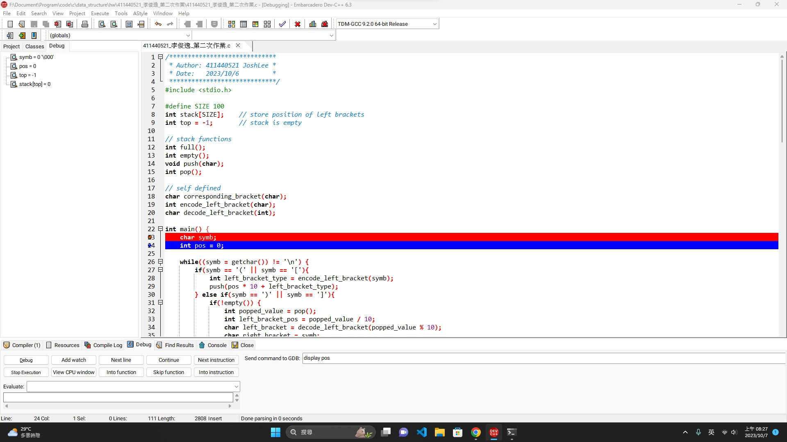

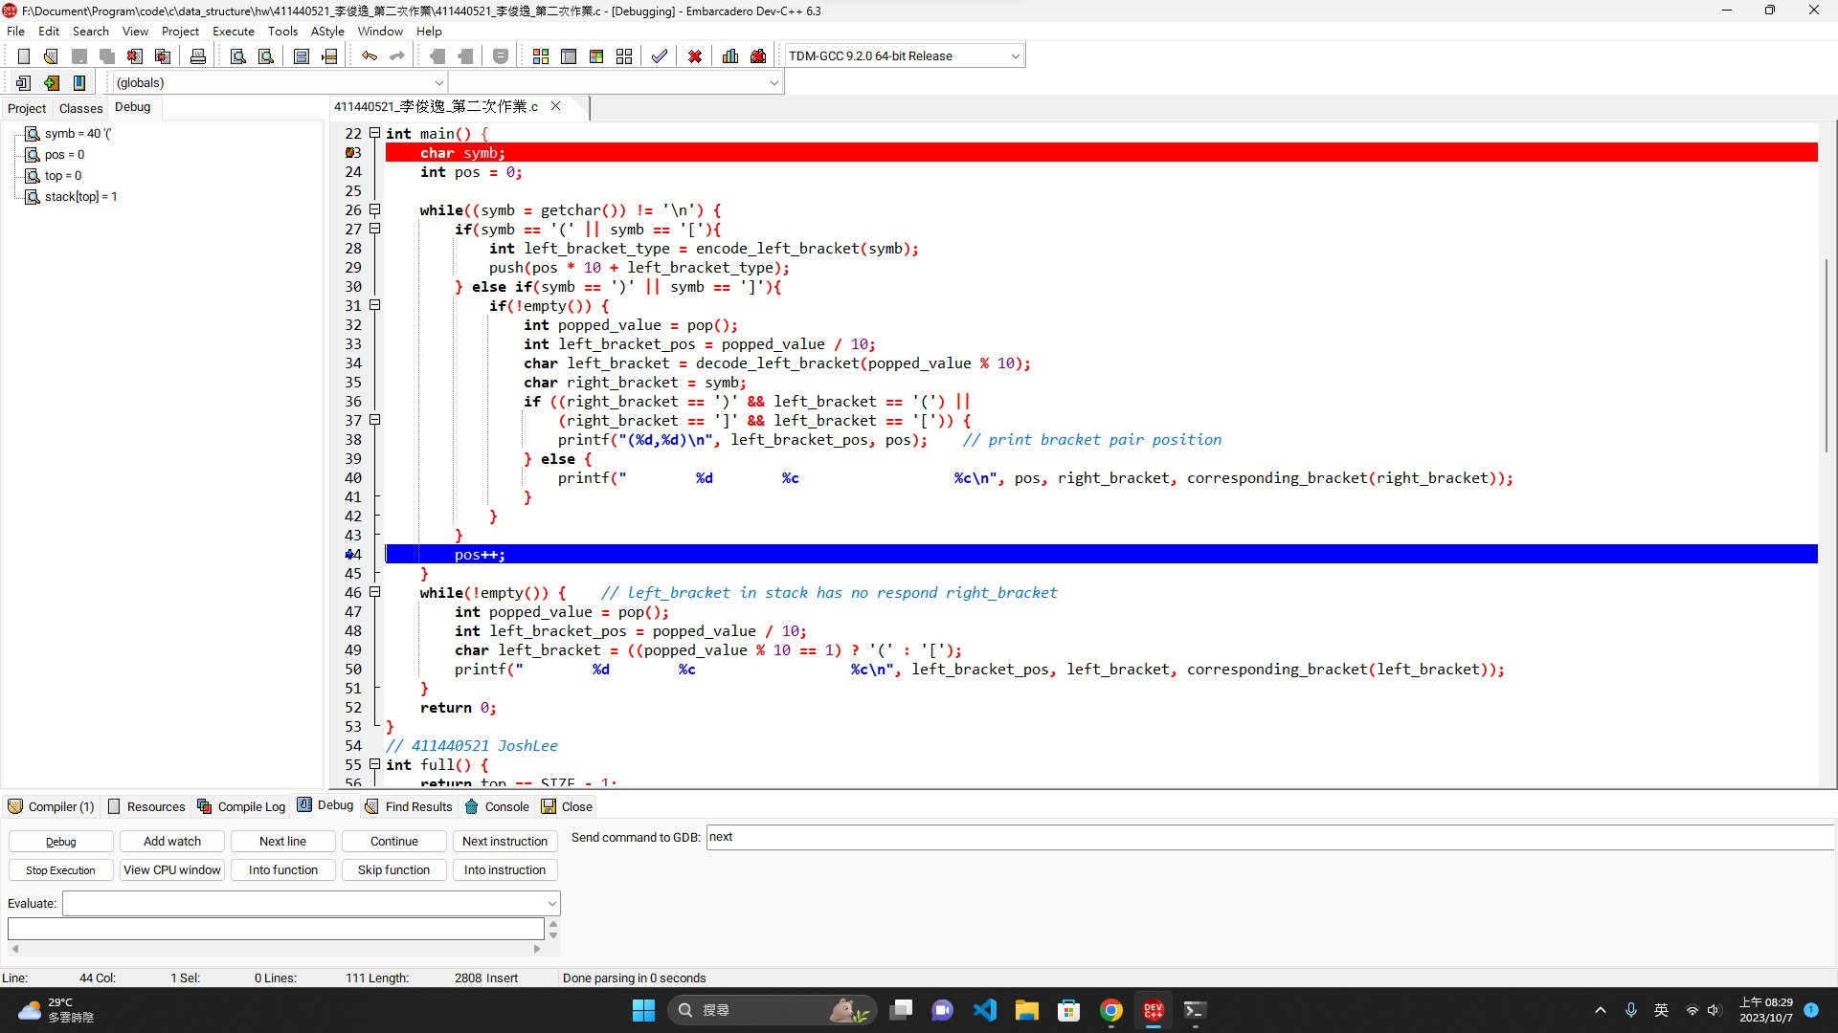

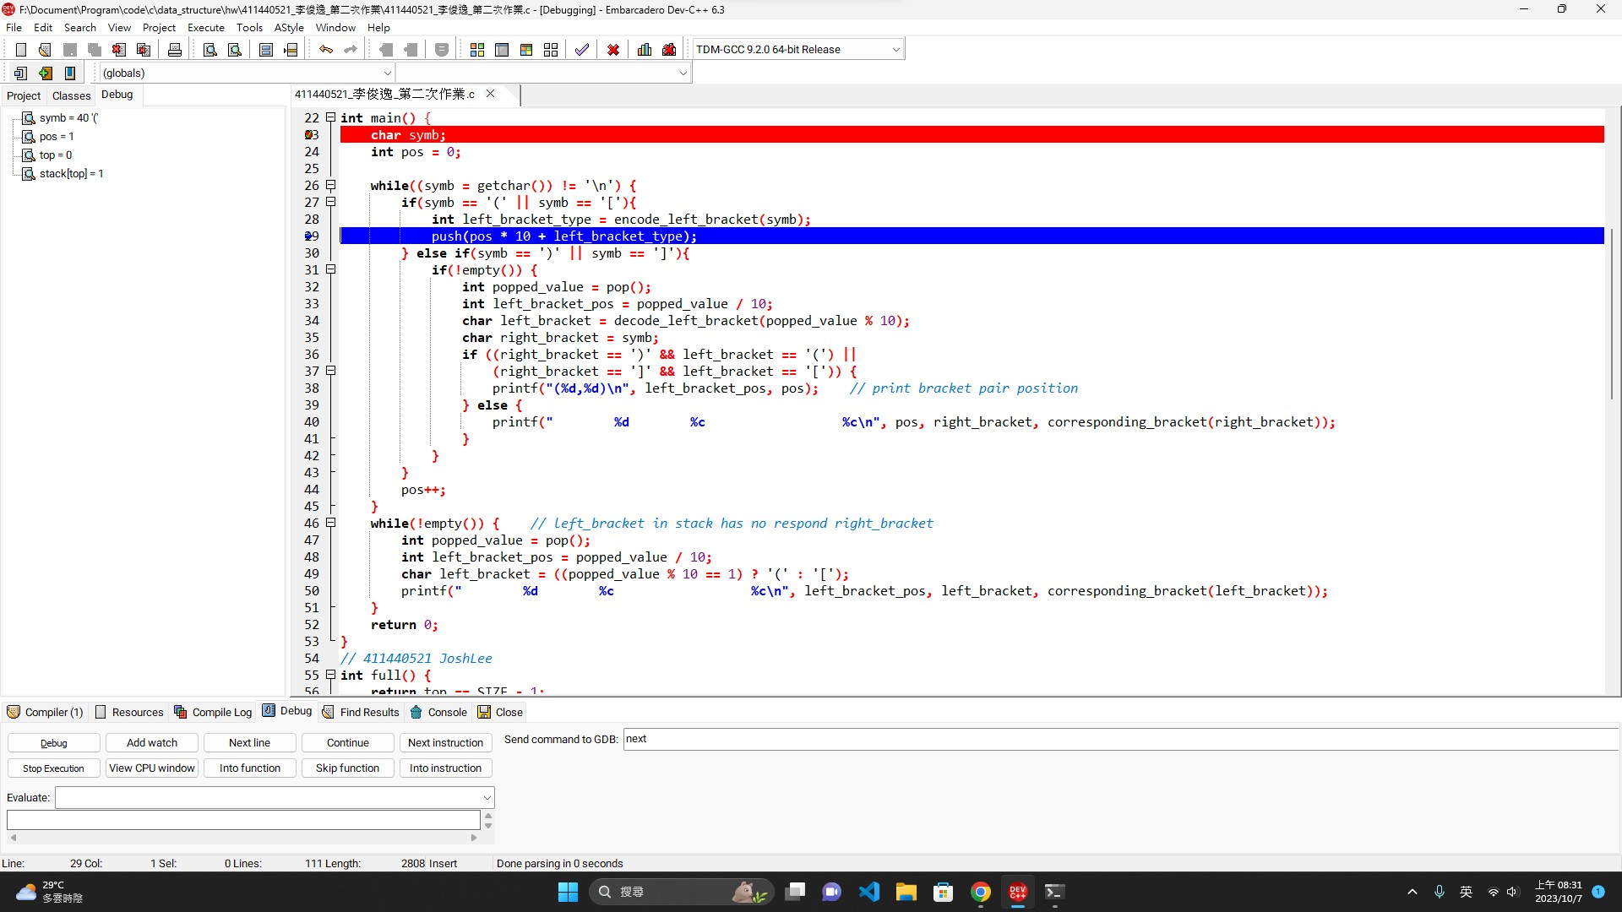

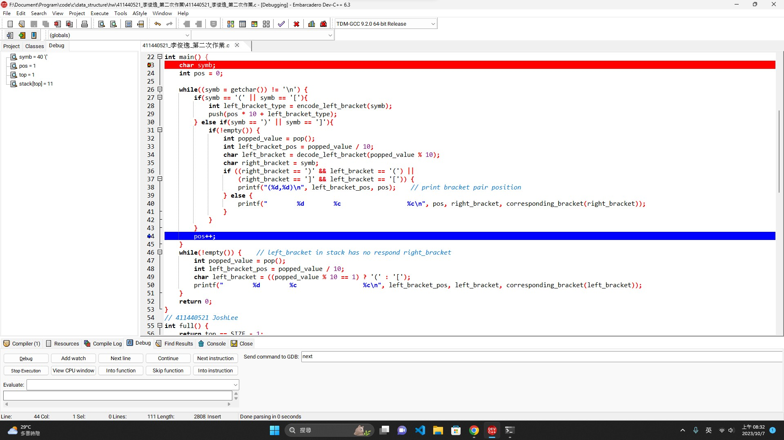

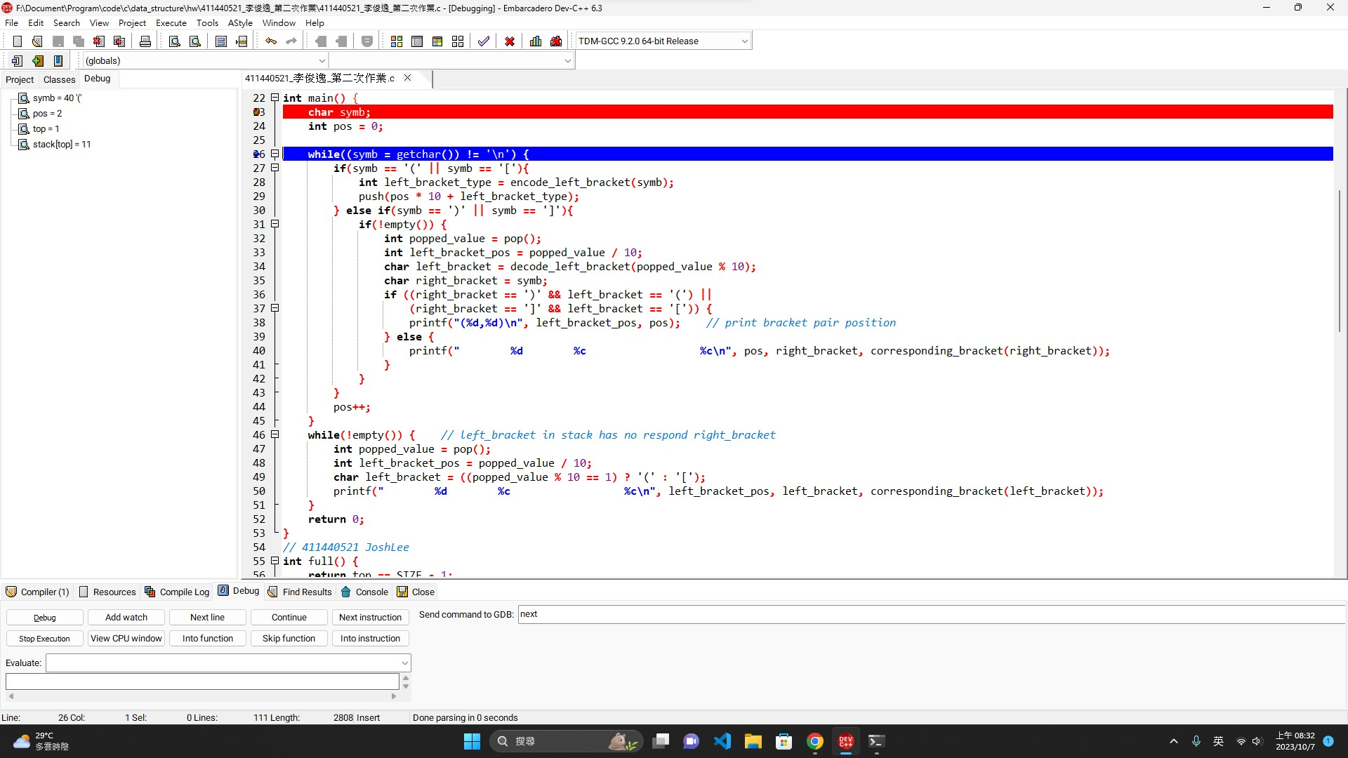

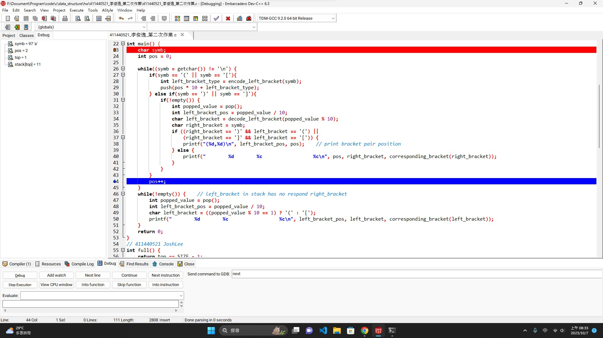

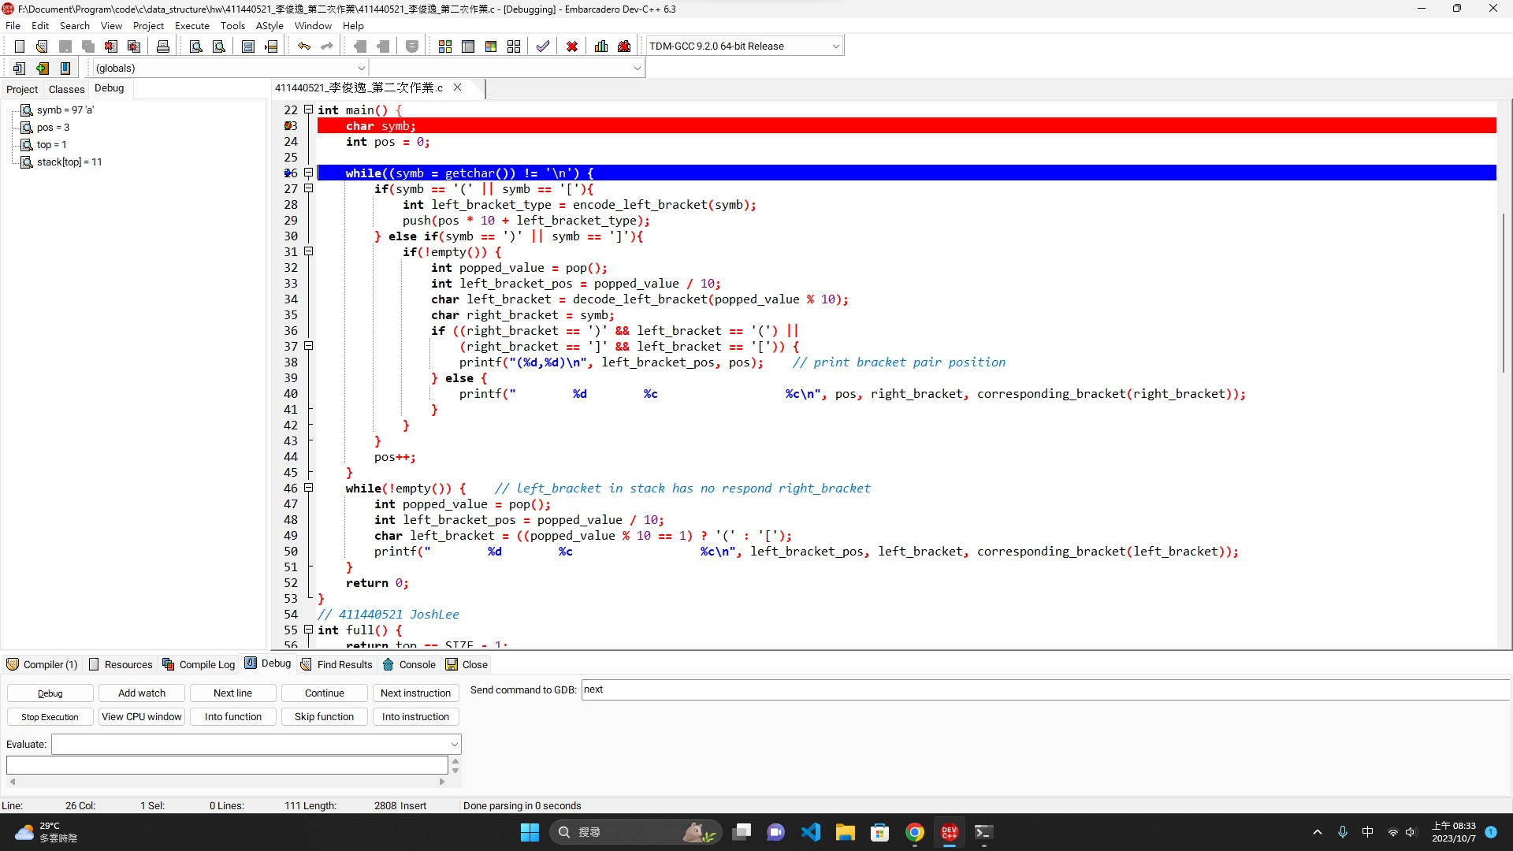

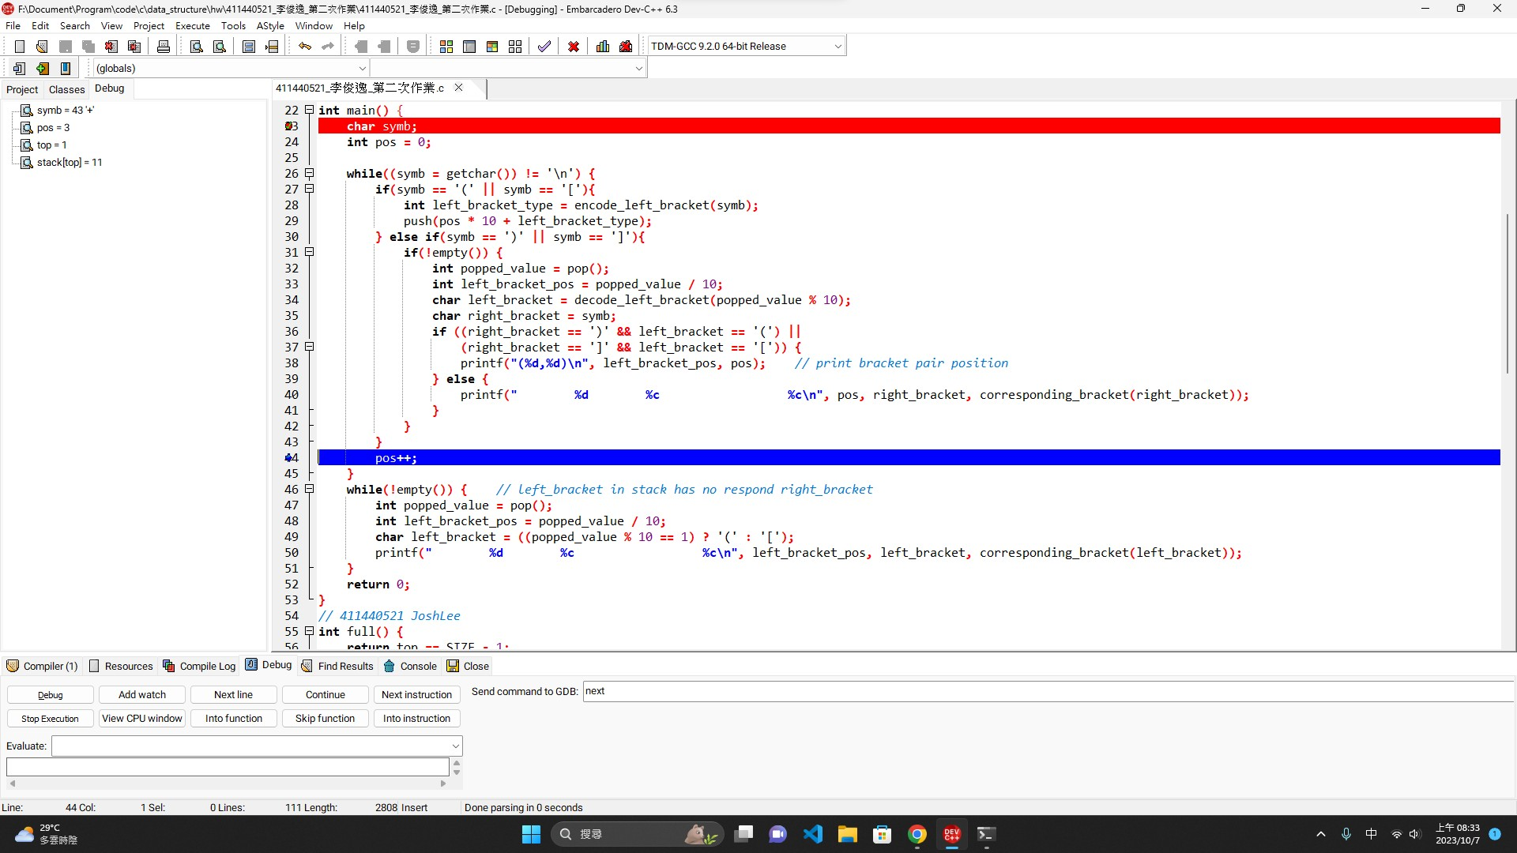

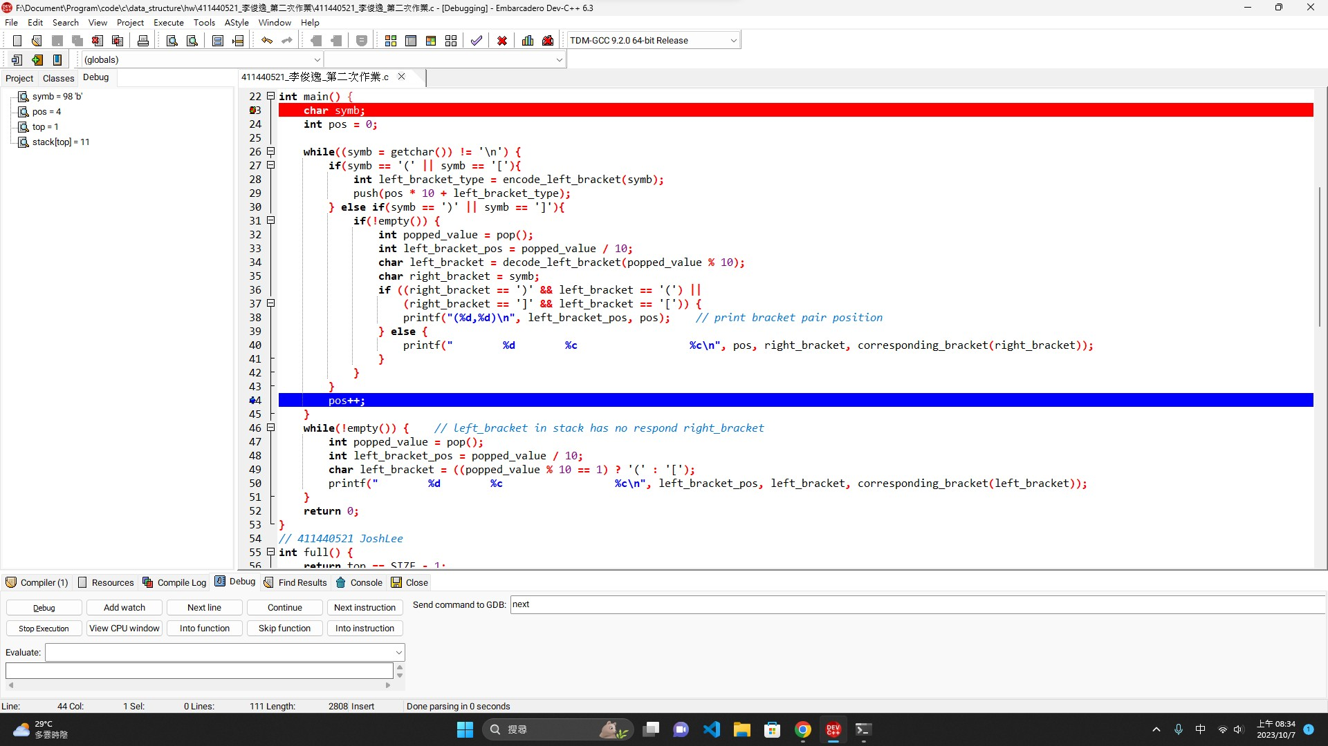

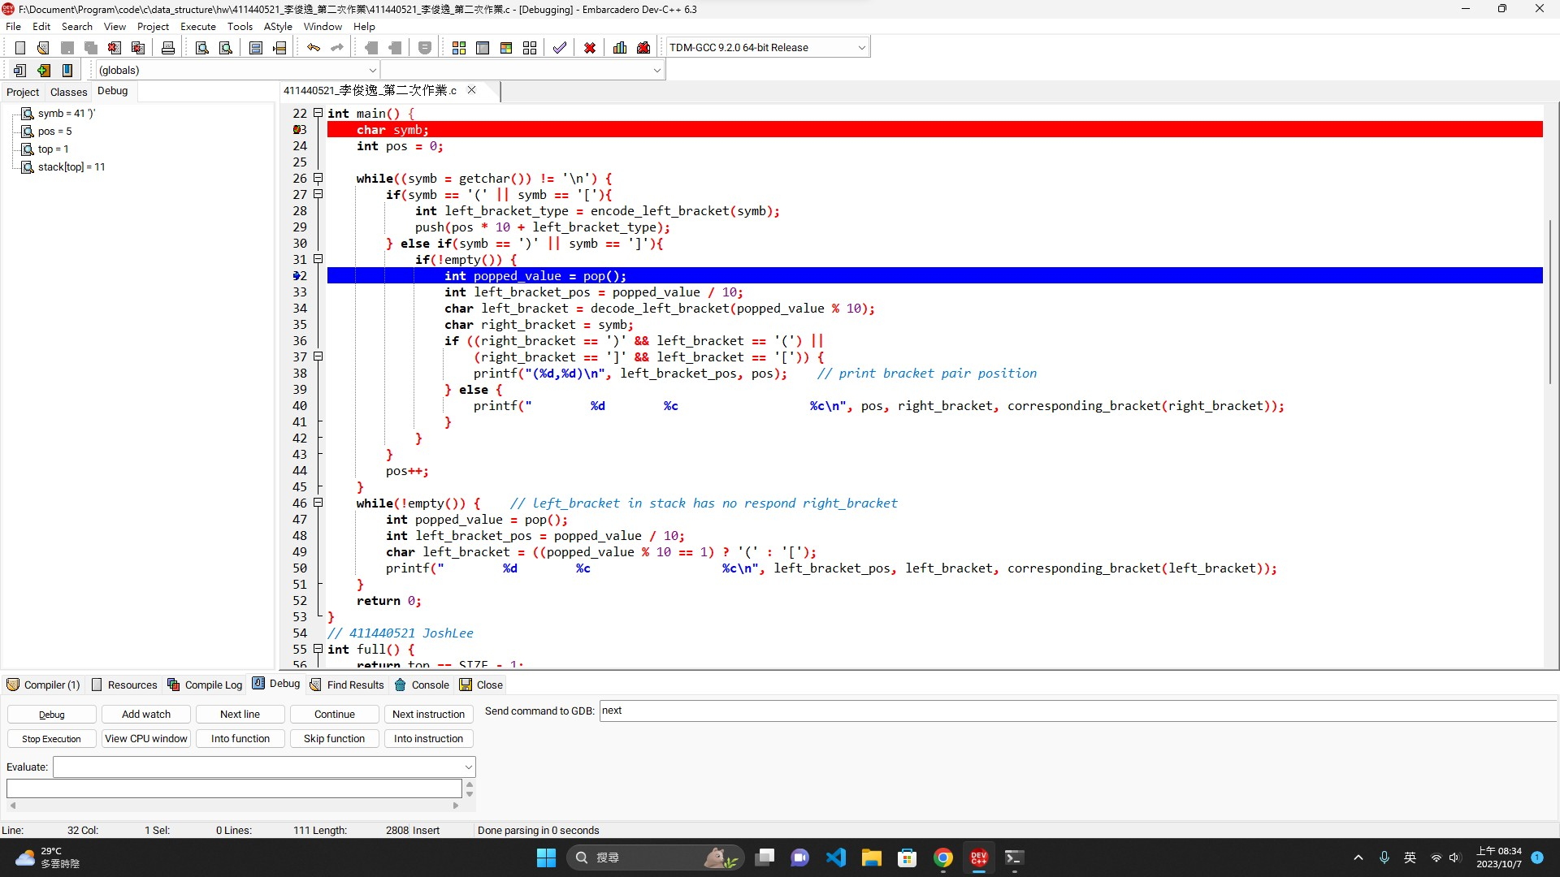

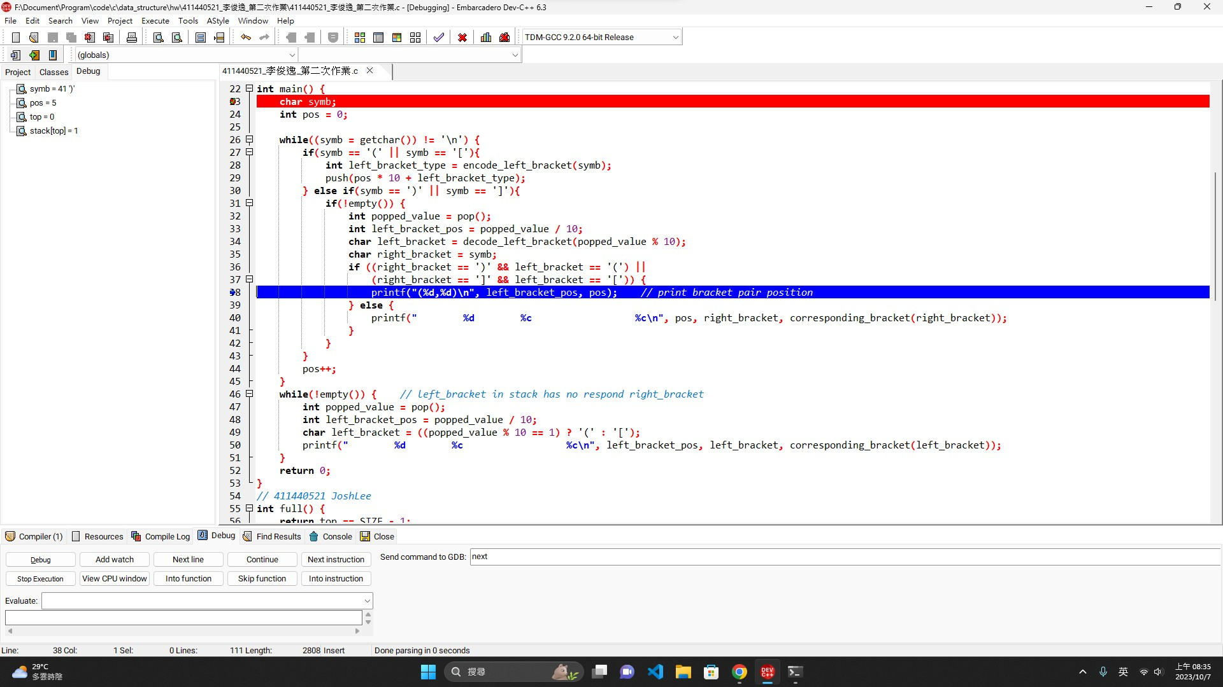

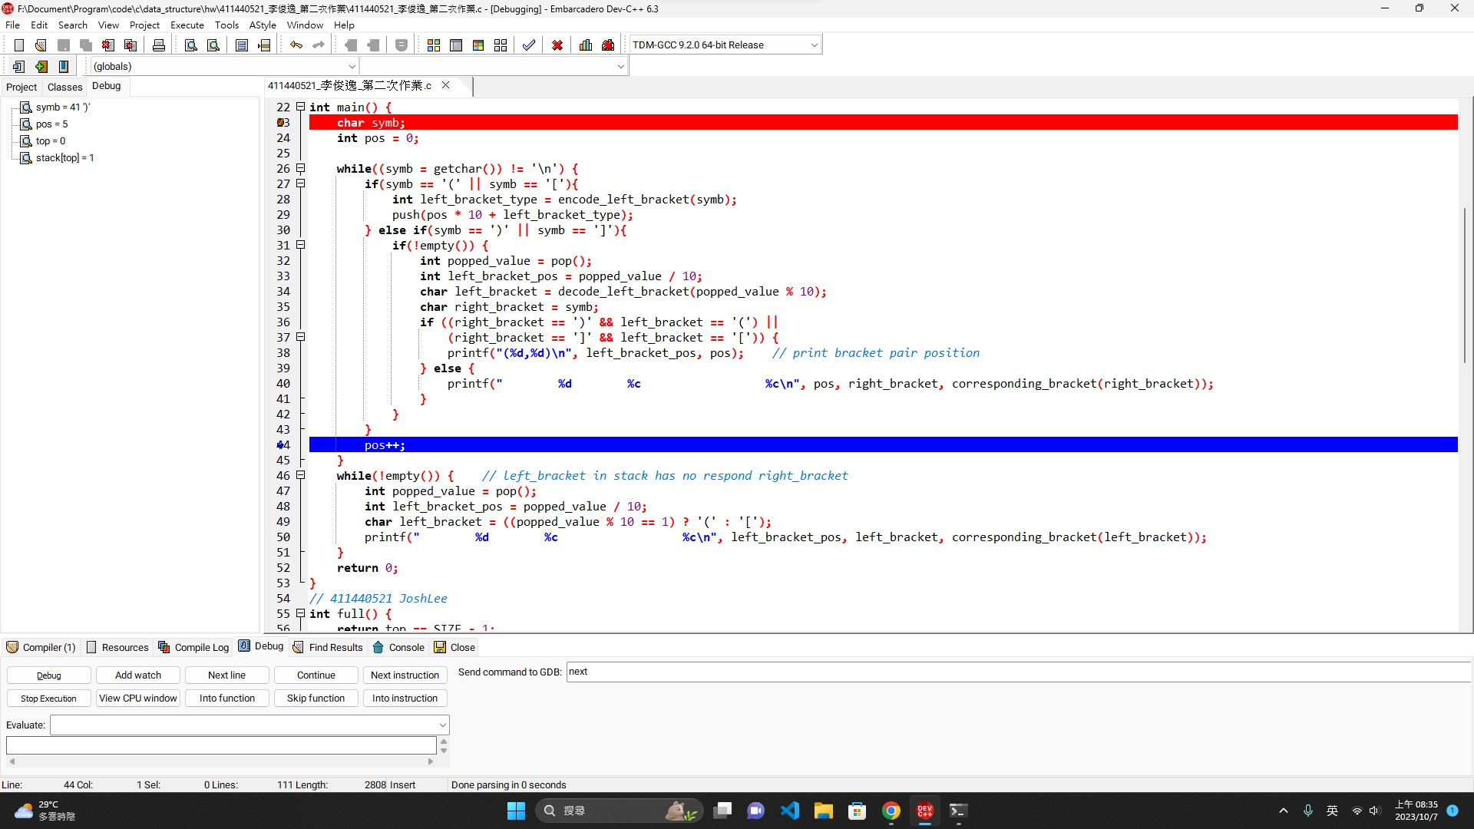

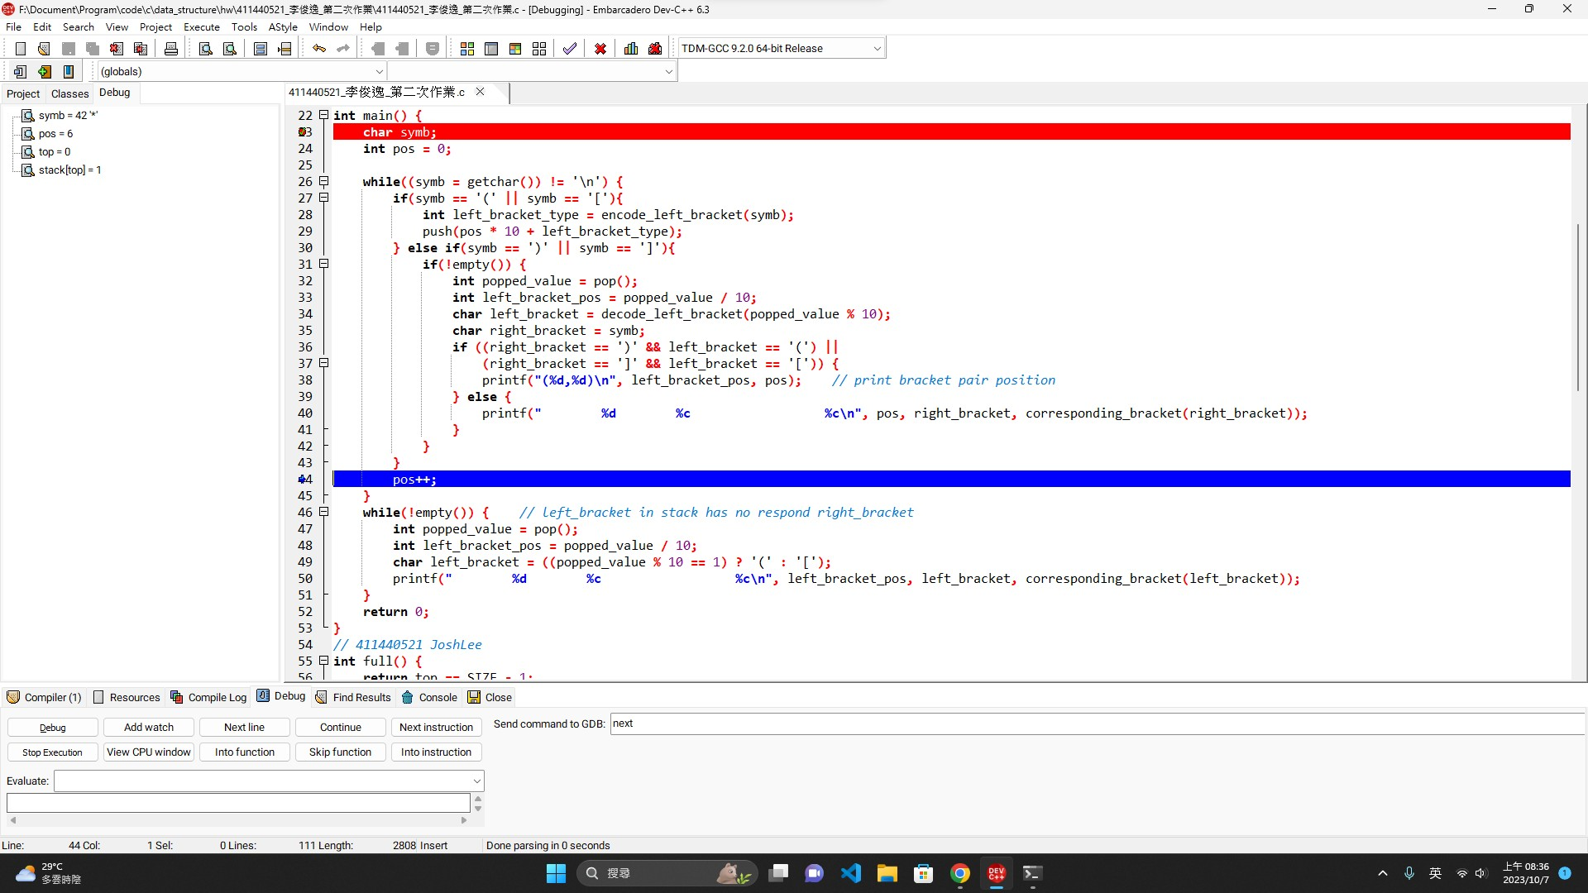

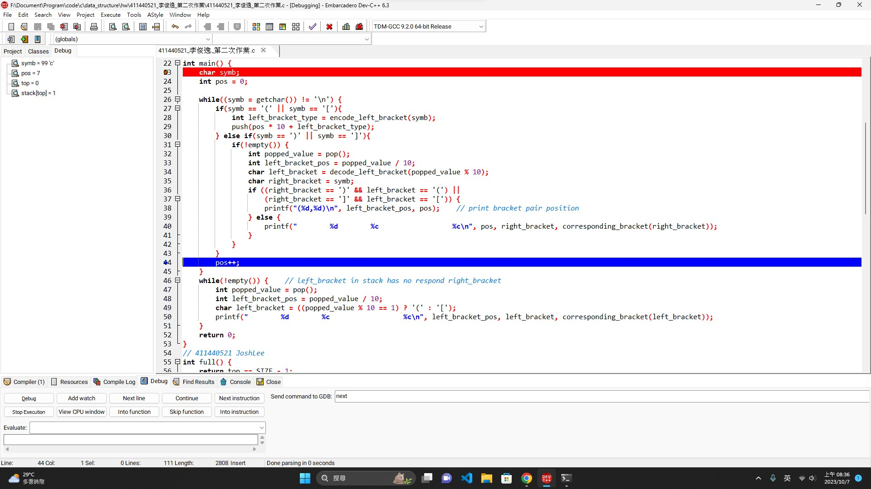

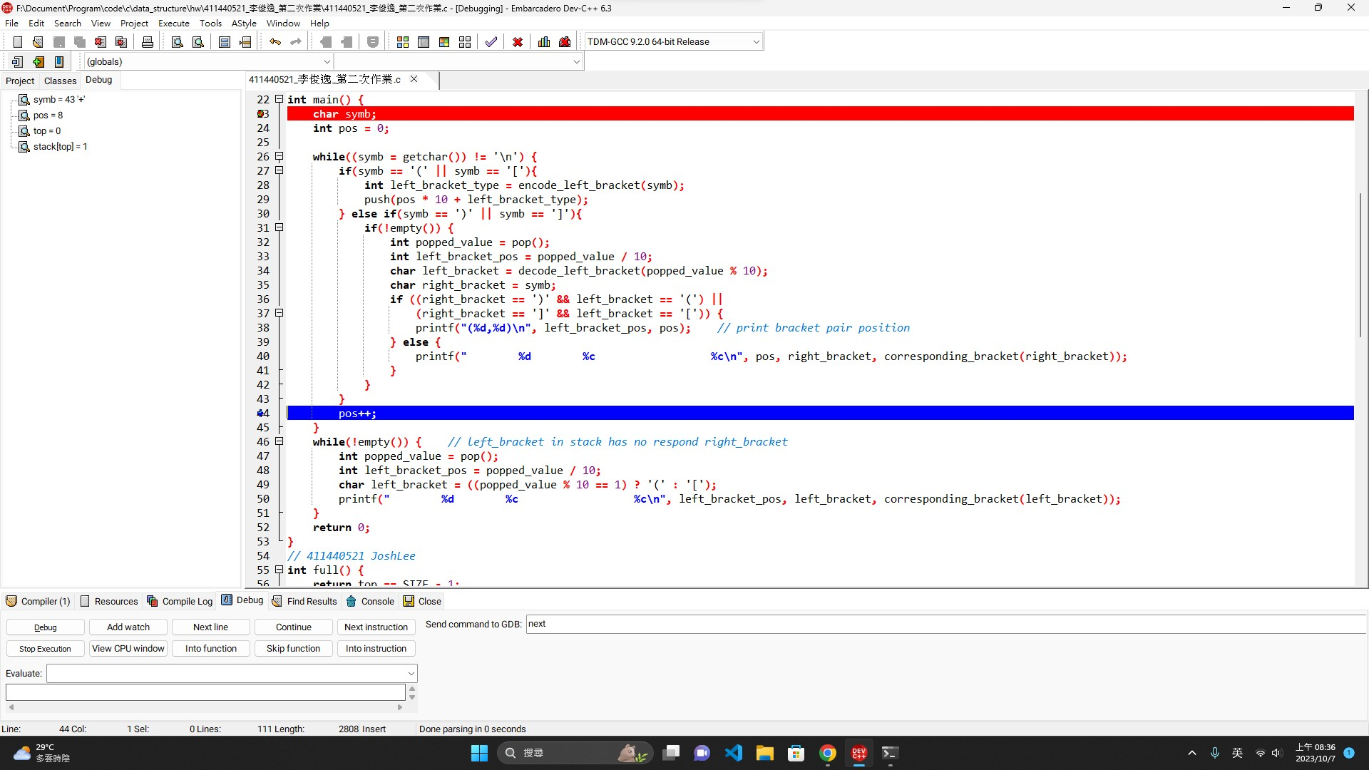

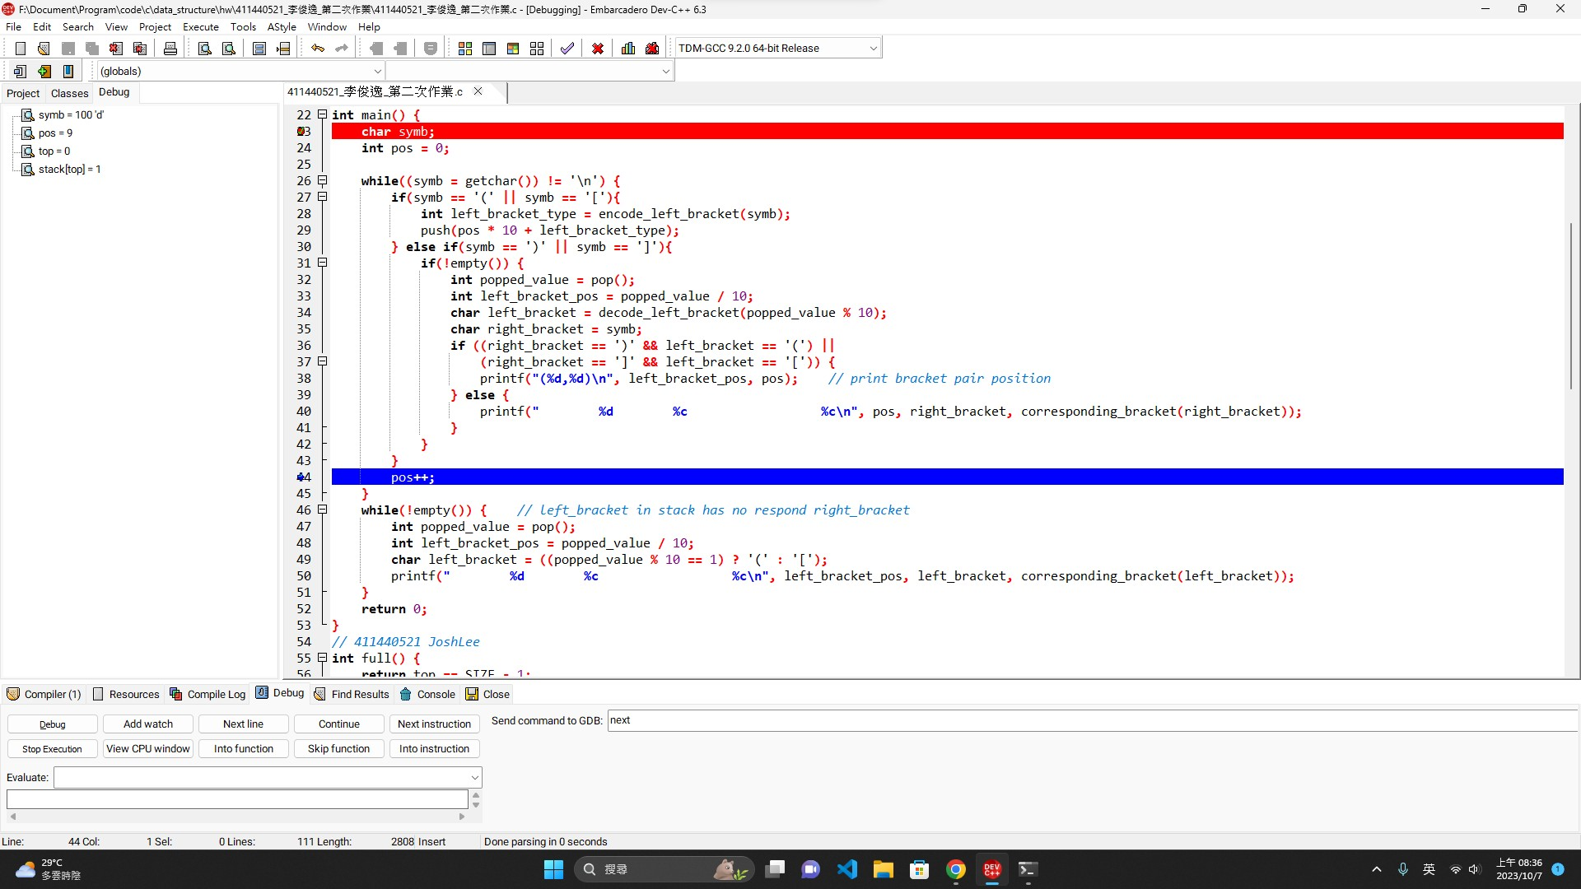

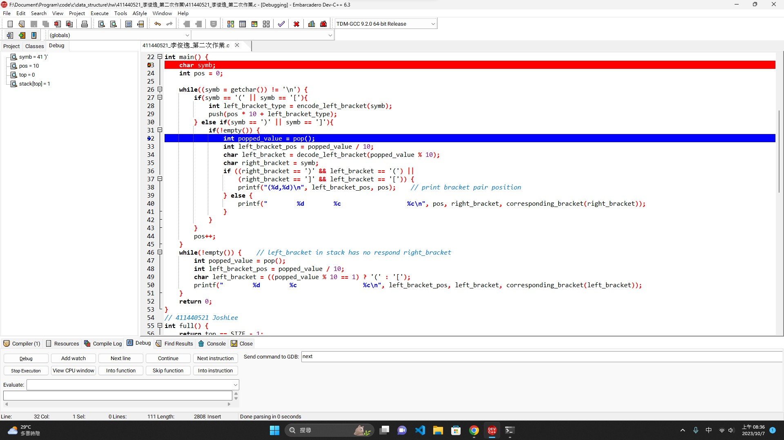

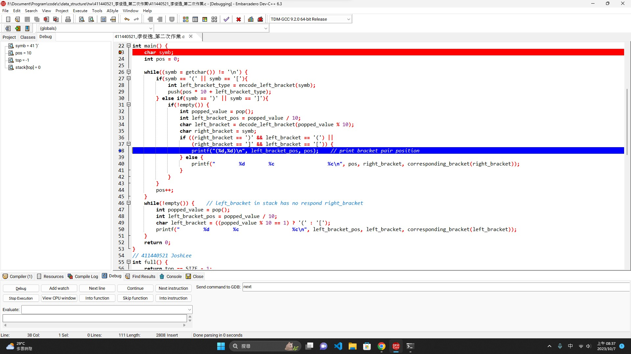

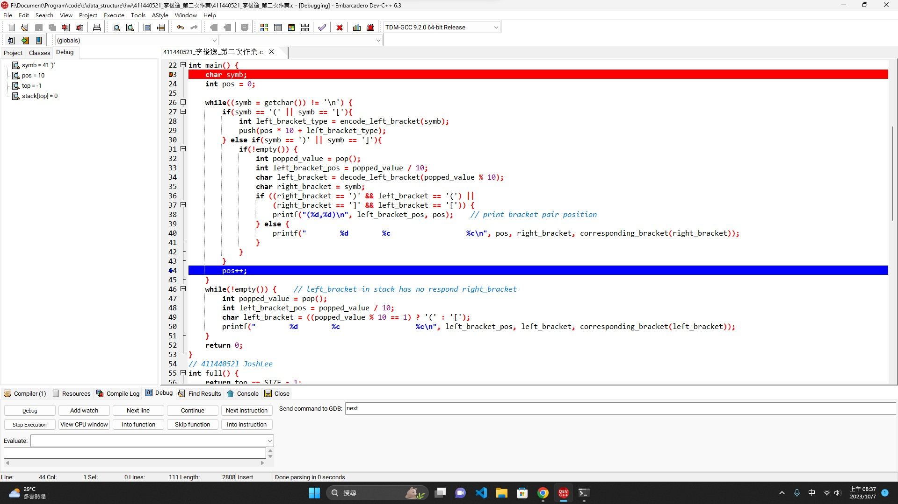

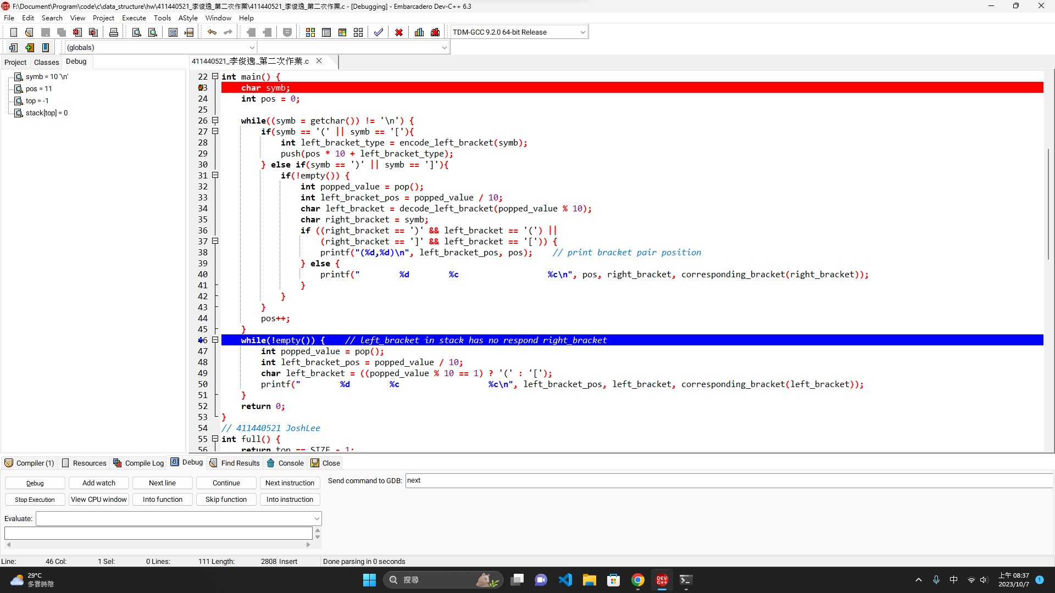

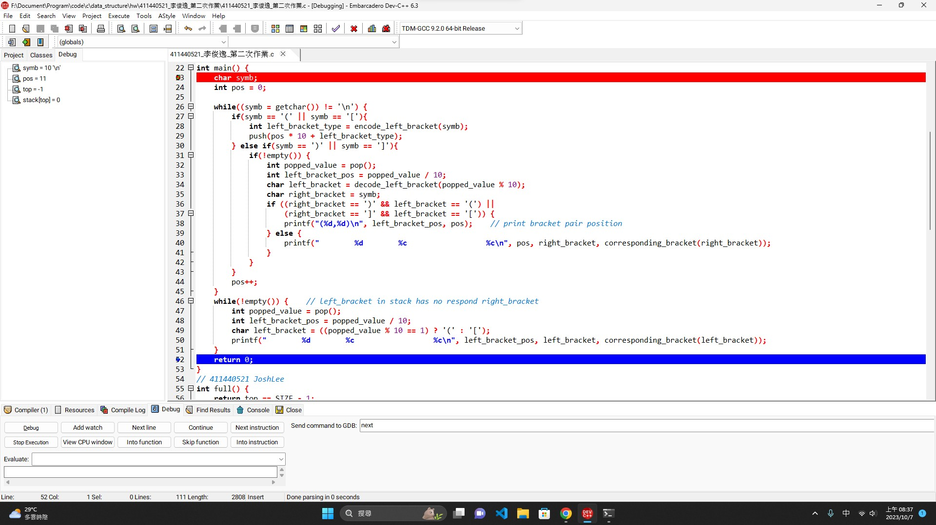

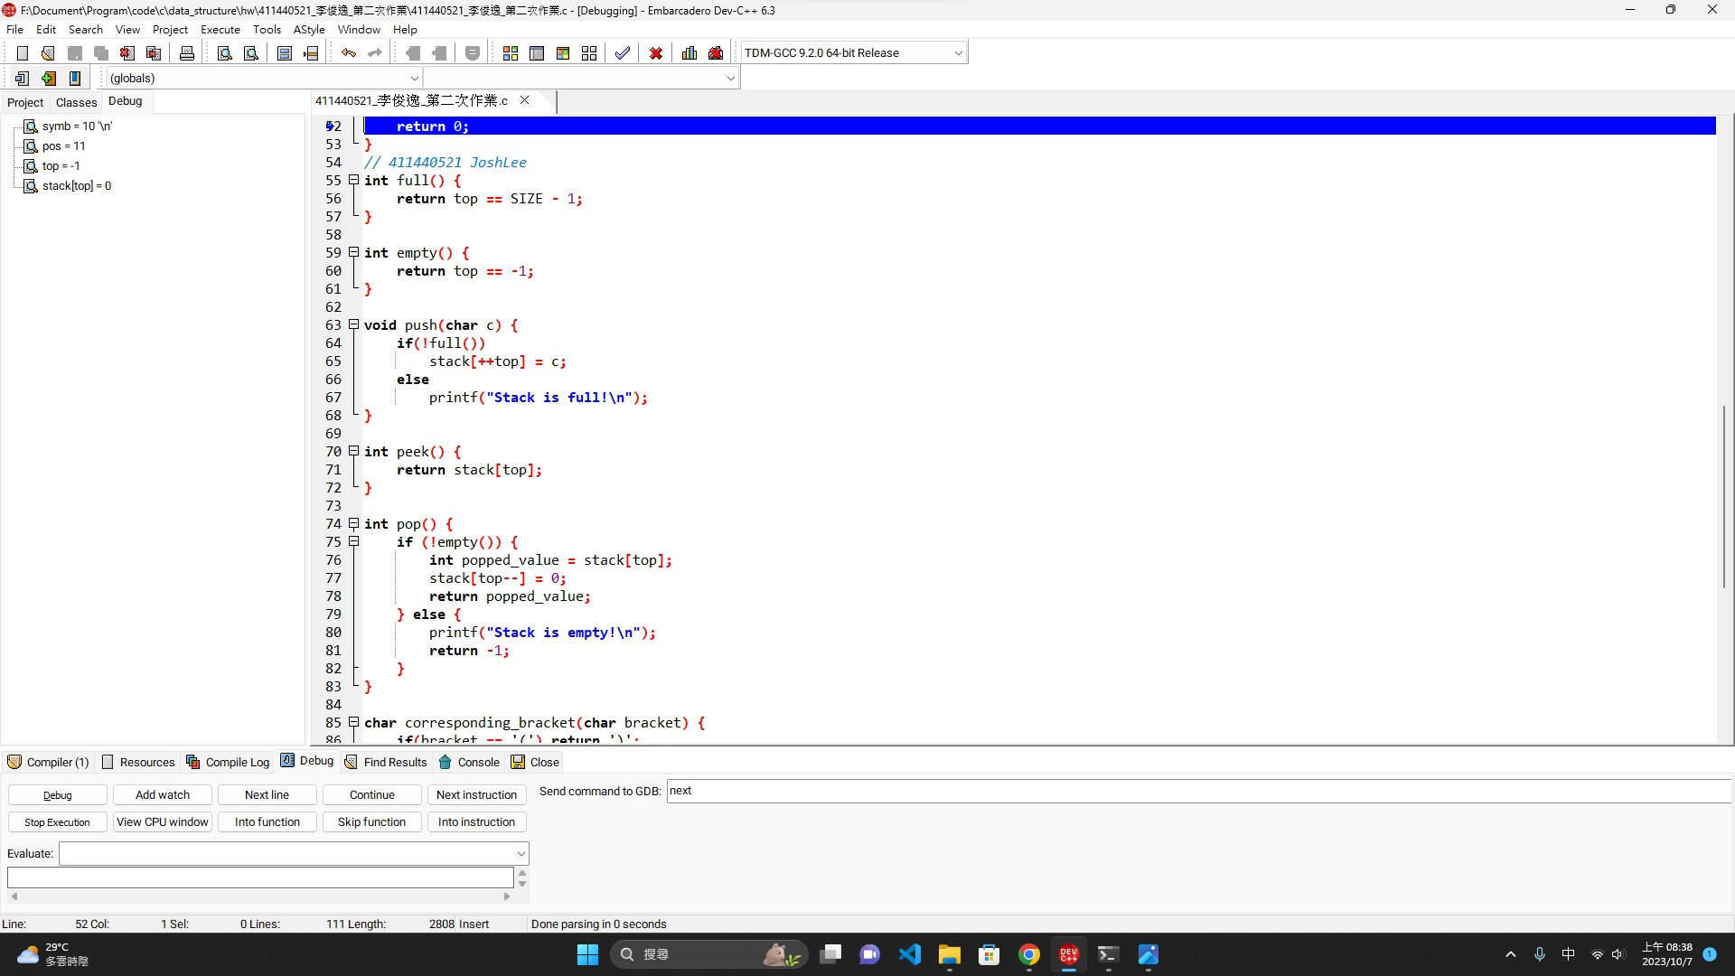

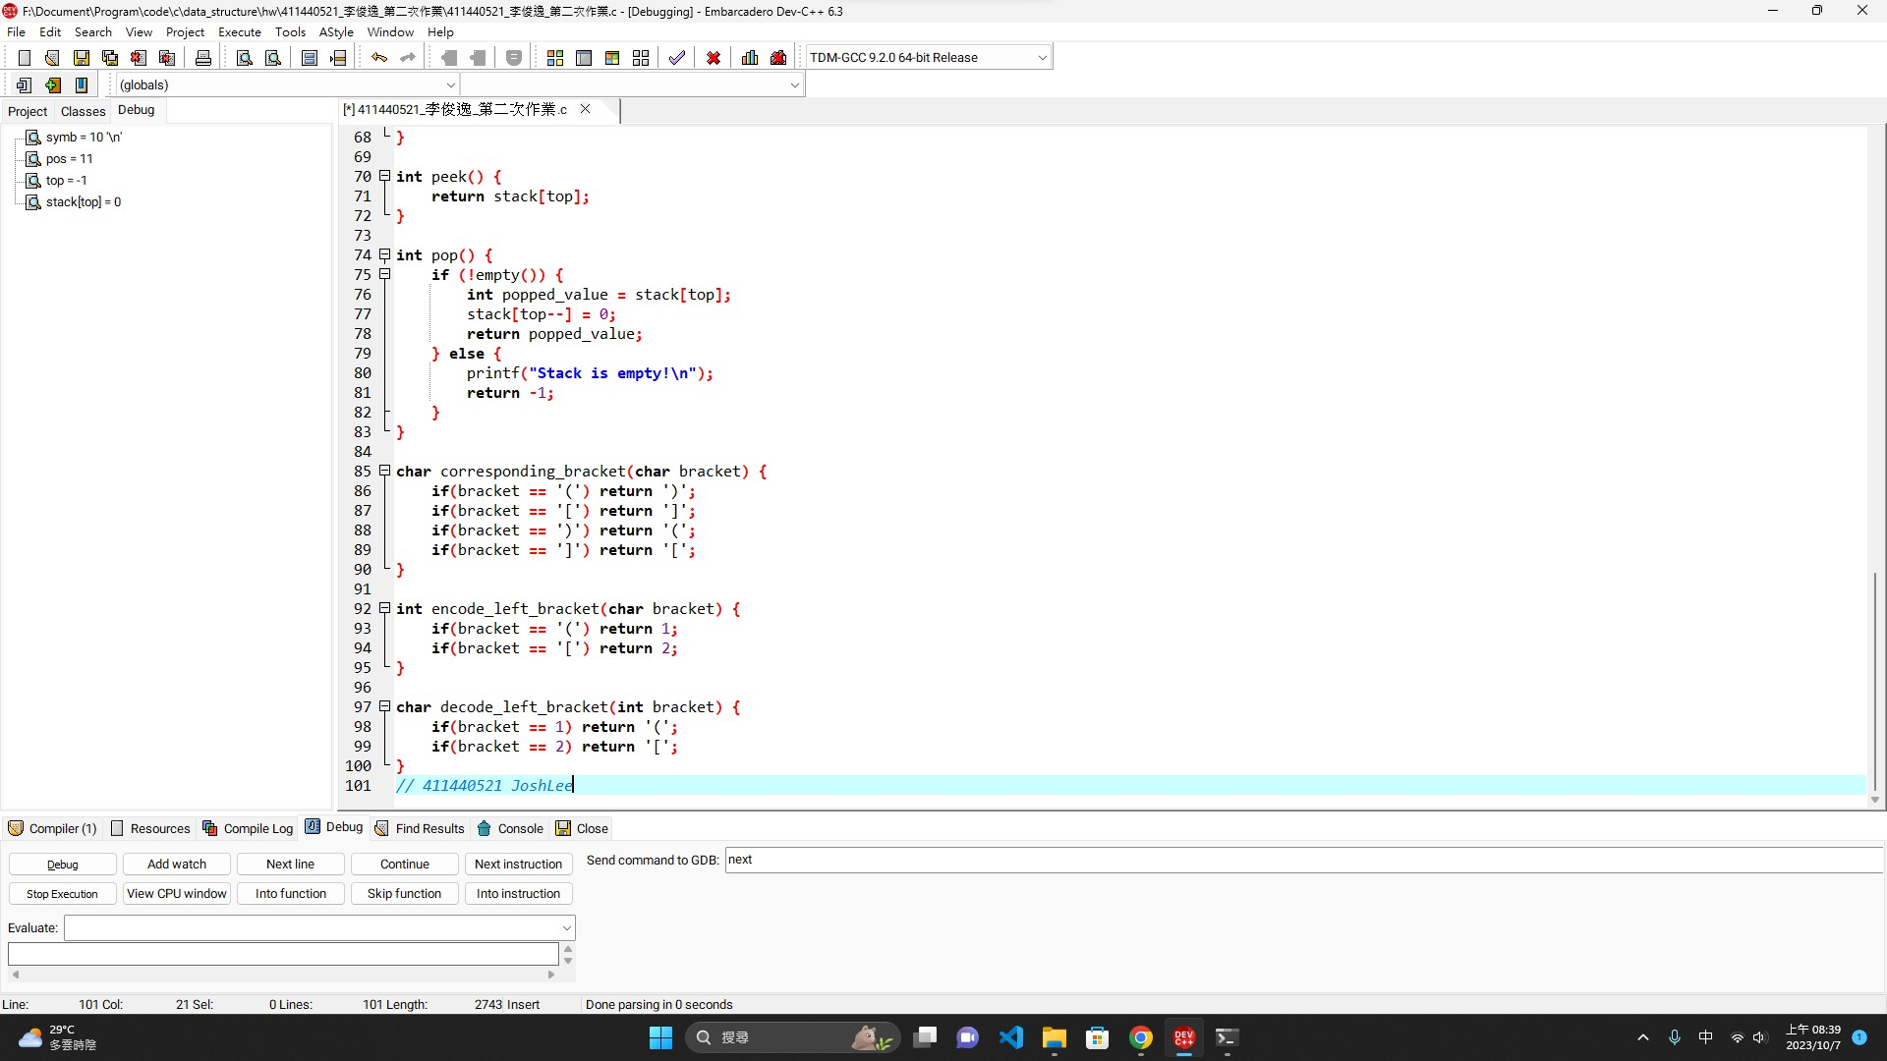

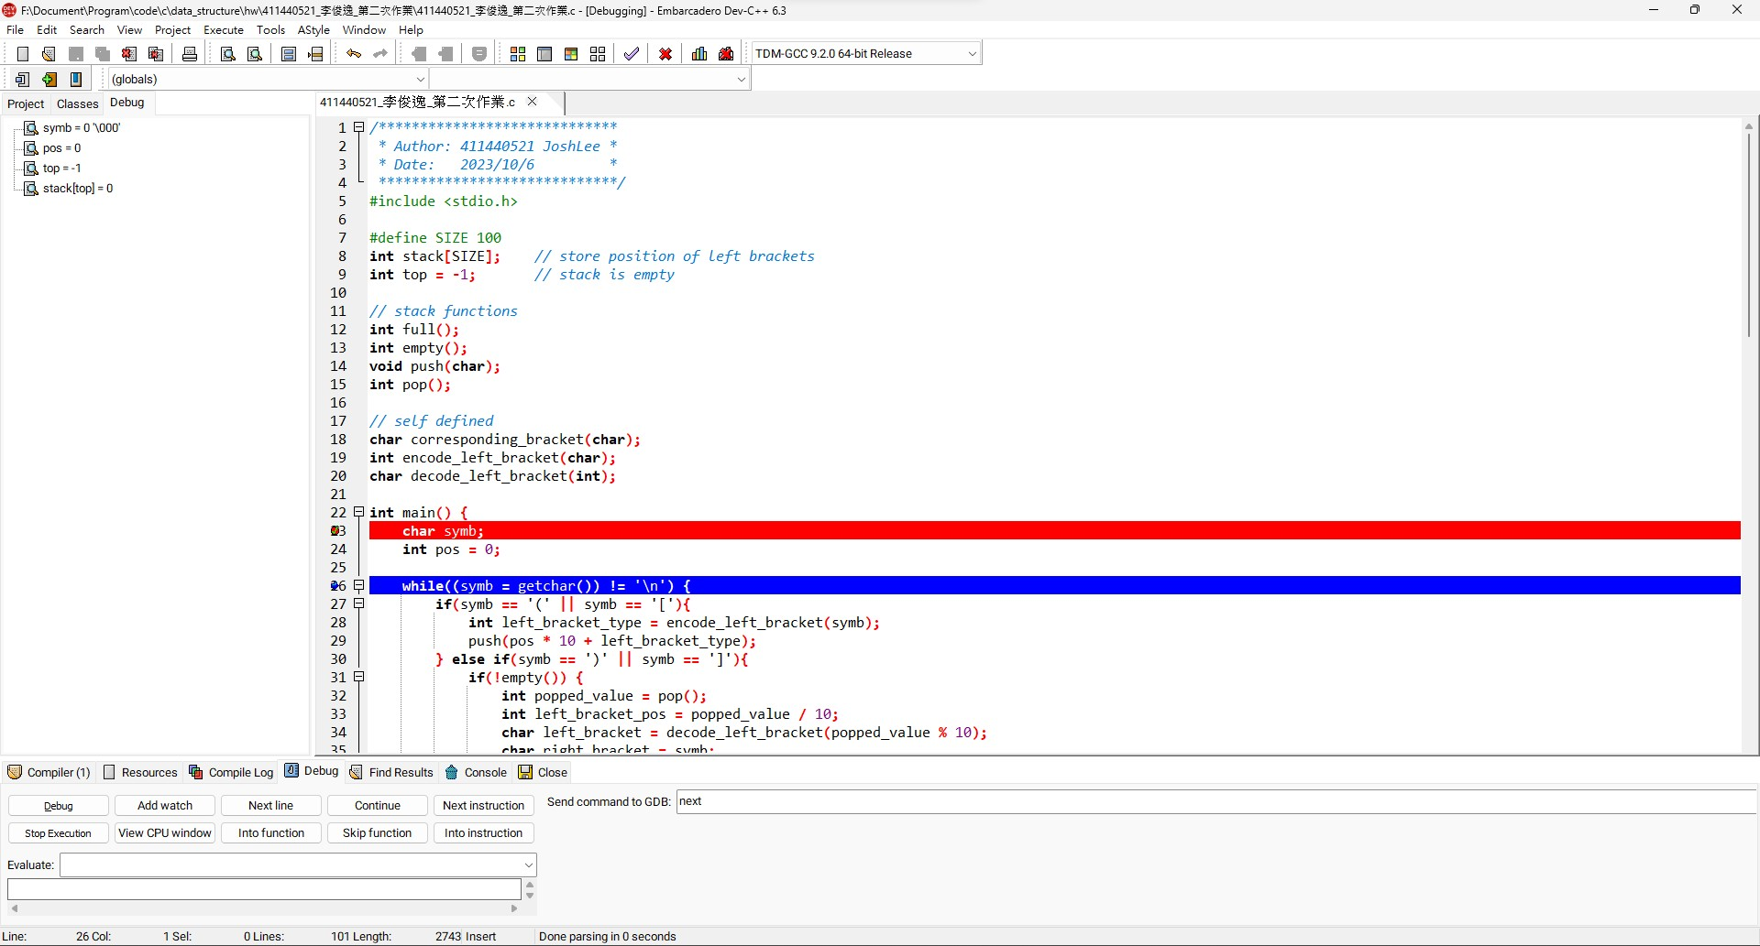

1. (a+b))*((c+d)

(0,4)

位置編號5的右括弧)沒有可配對的左括弧(

(8,12)

位置編號7的左括弧(沒有可配對的右括弧)

( 7

遇到 ) @4

pop()最上層的(

(0,4)

( 8

( 7

遇到 ) @5

pop()發現沒有左括弧

位置編號5的右括弧)沒有可配對的左括弧(

遇到 ) @12

pop()最上層的(

(8,12)

( 0

位置編號7的左括弧(沒有可配對的右括弧)

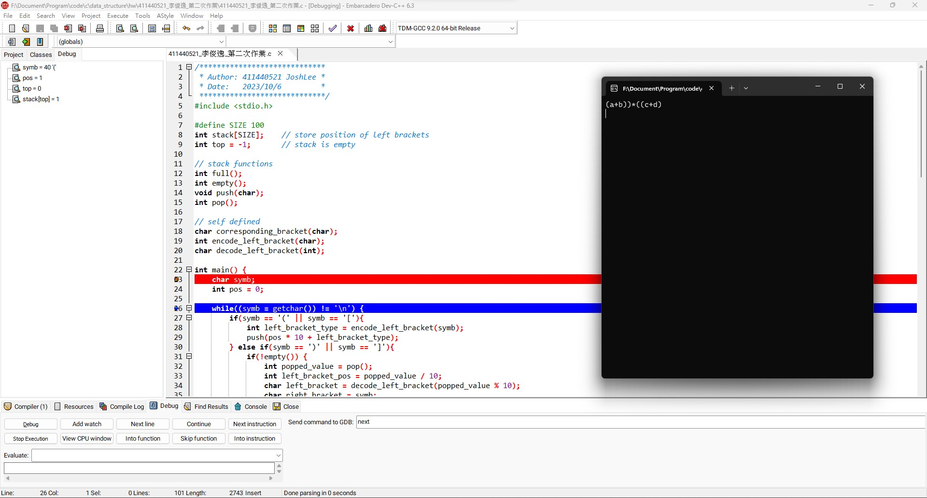

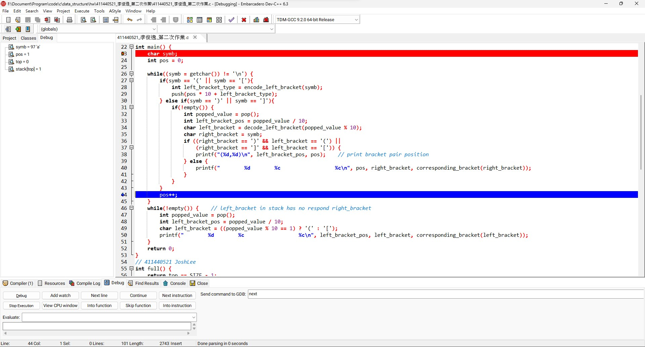

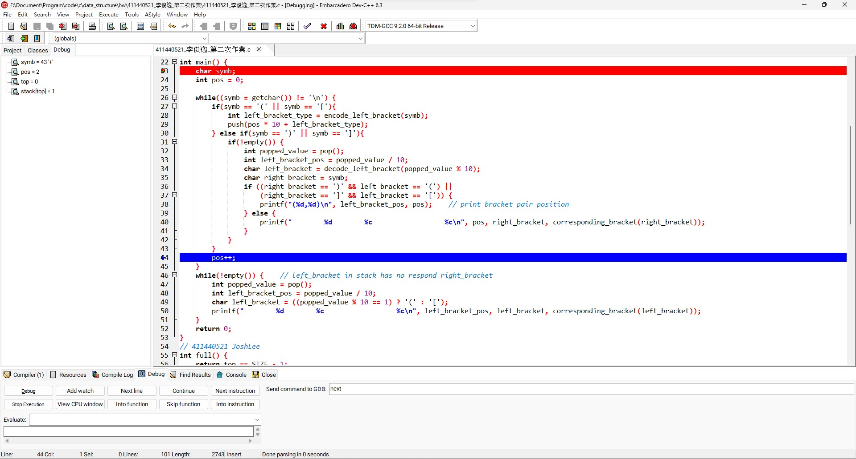

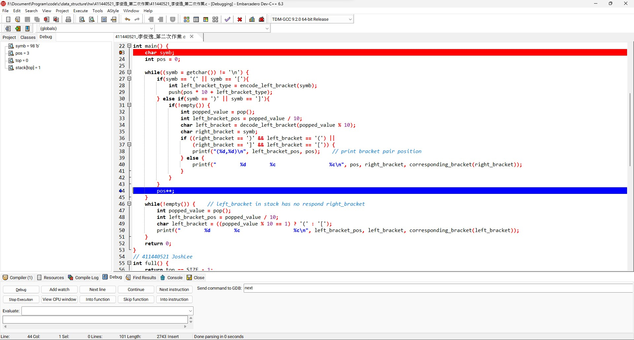

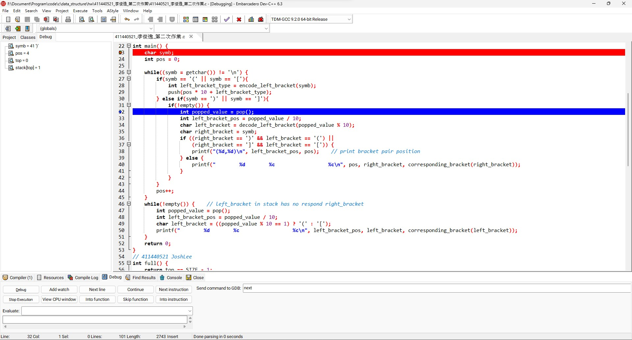

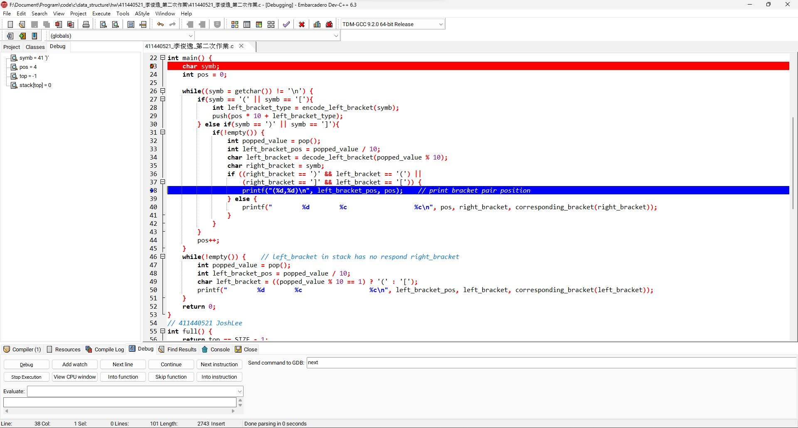

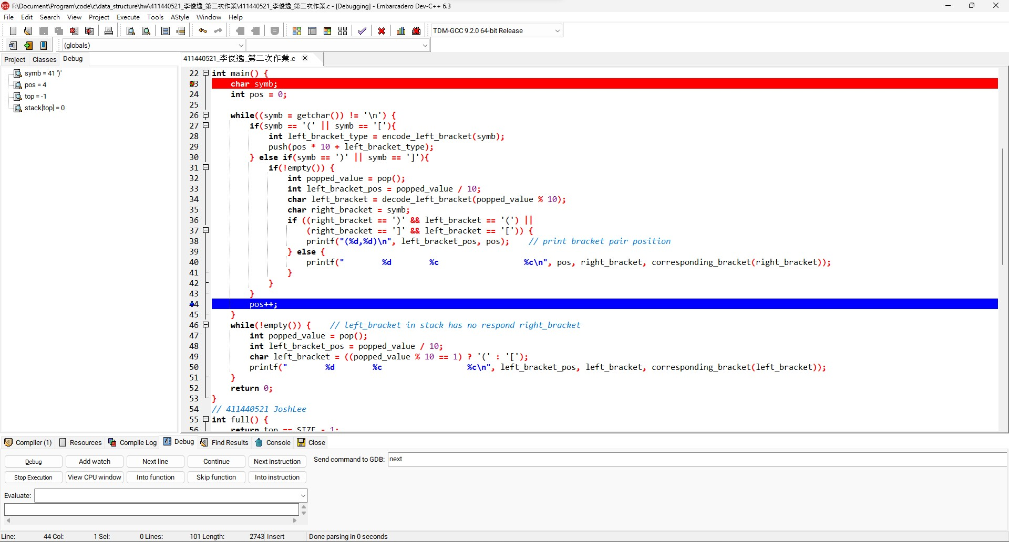

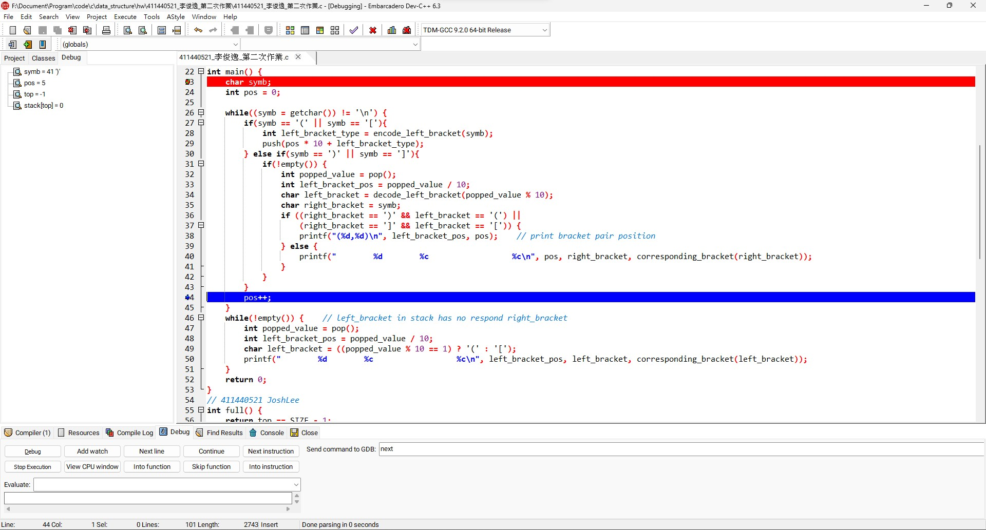

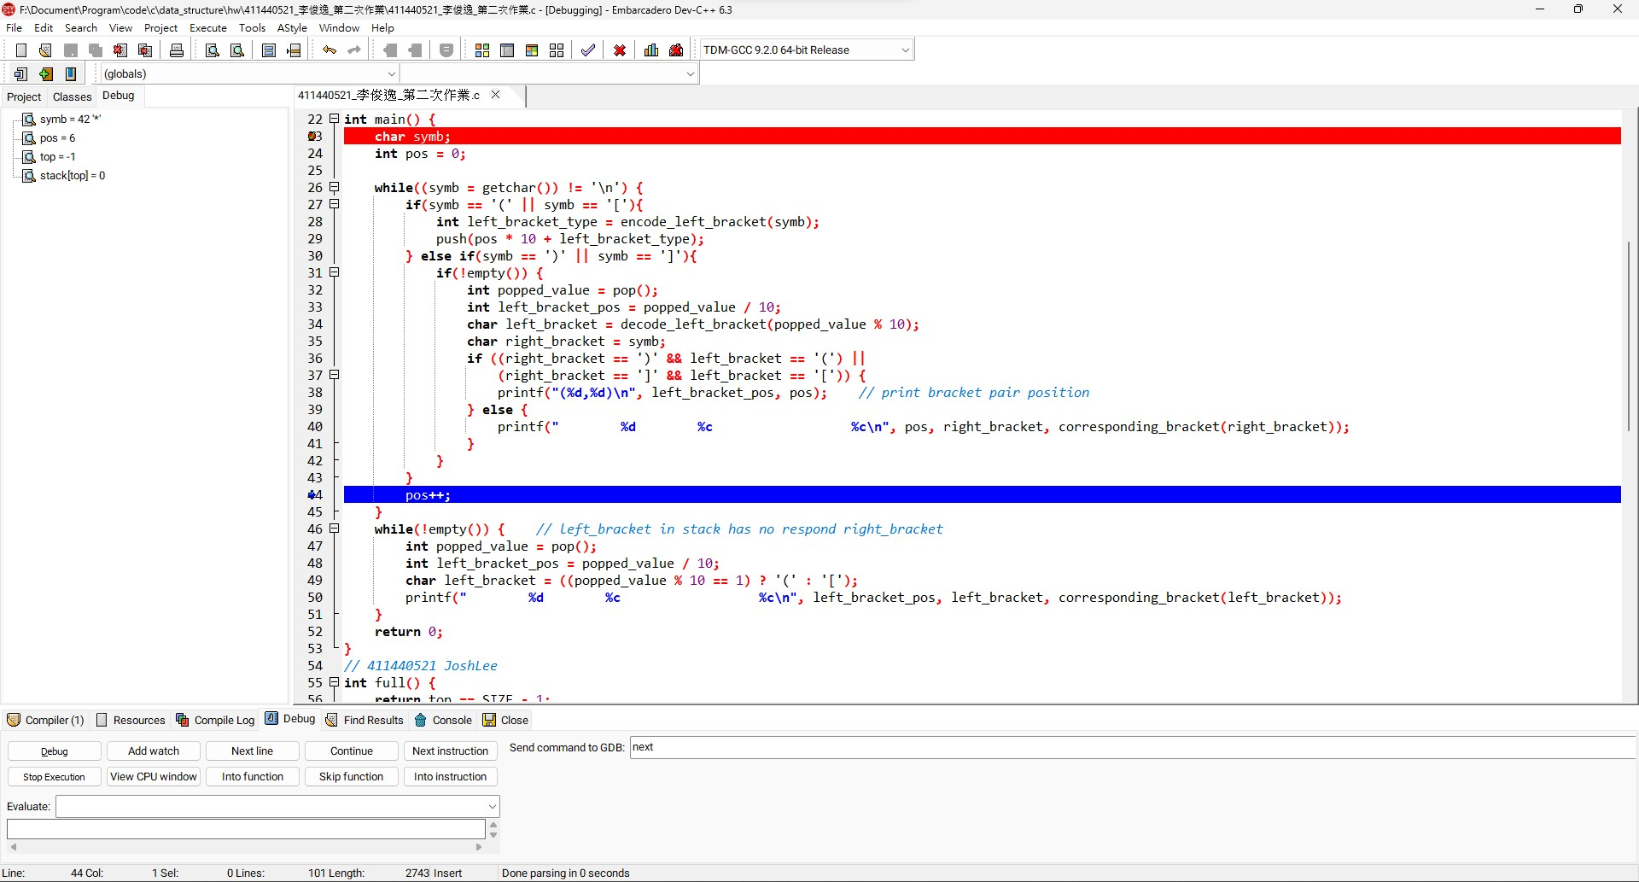

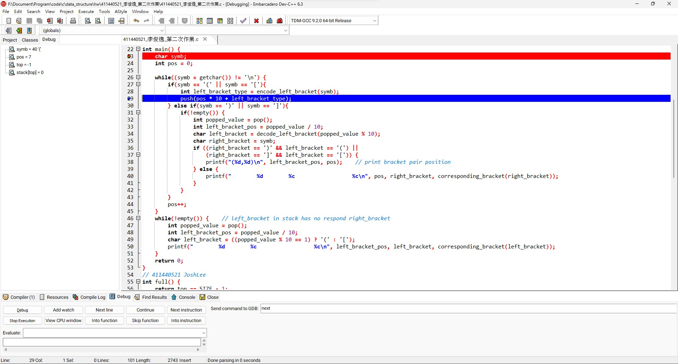

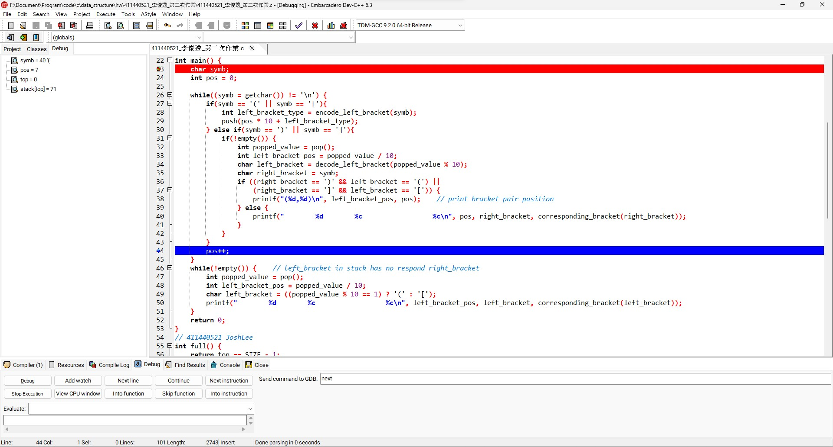

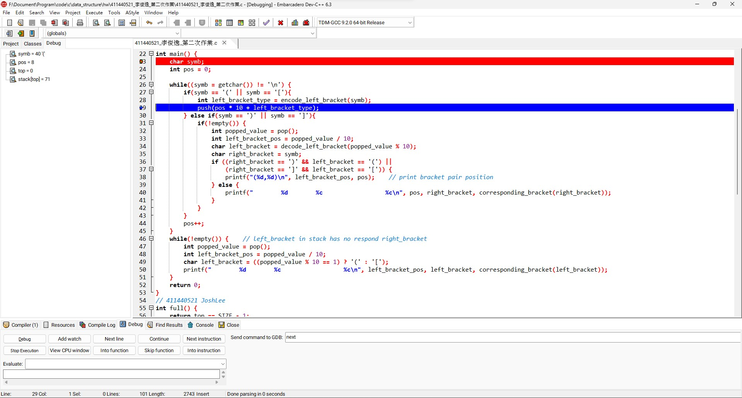

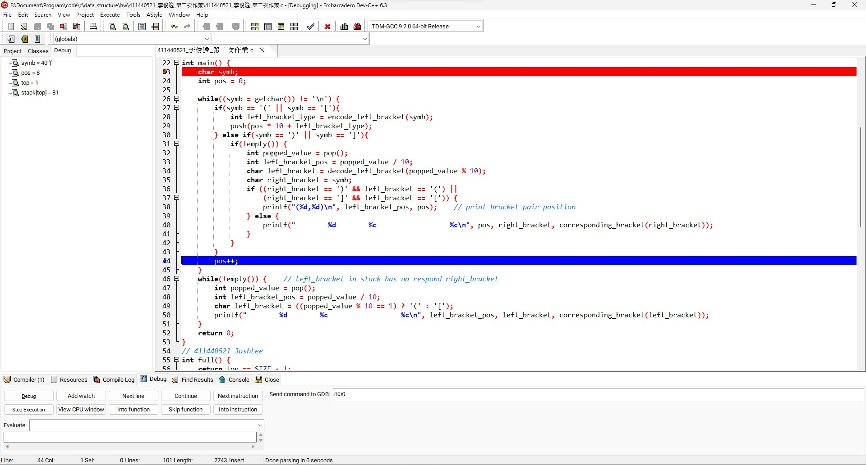

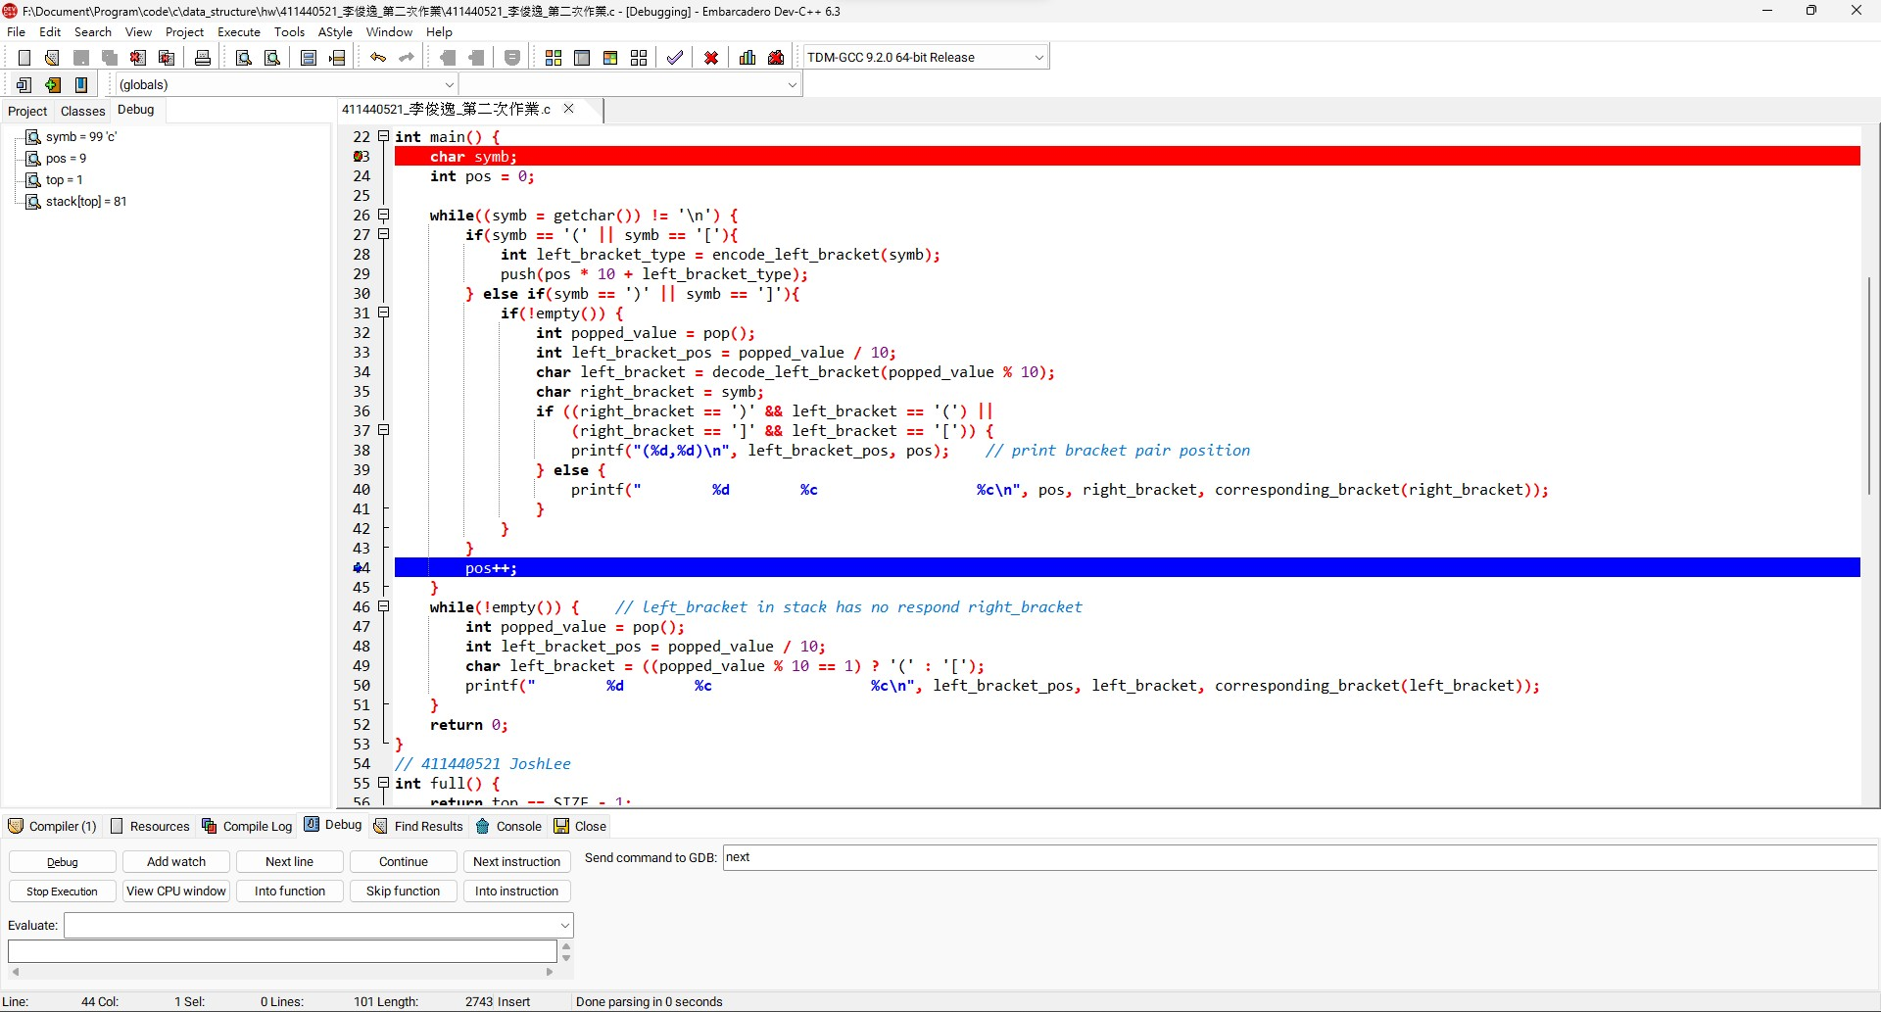

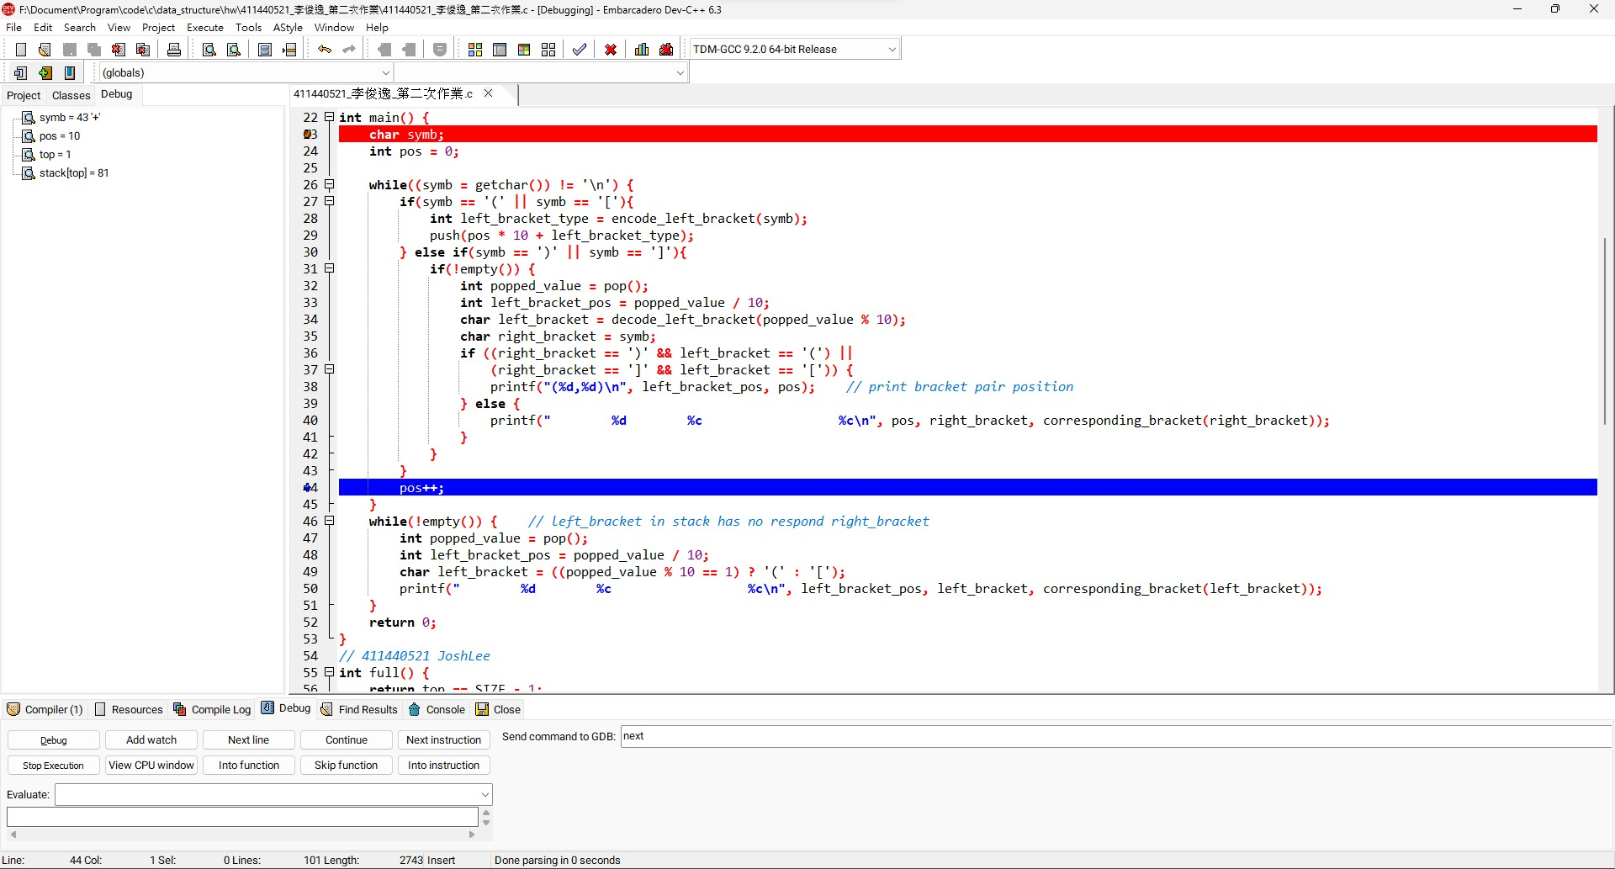

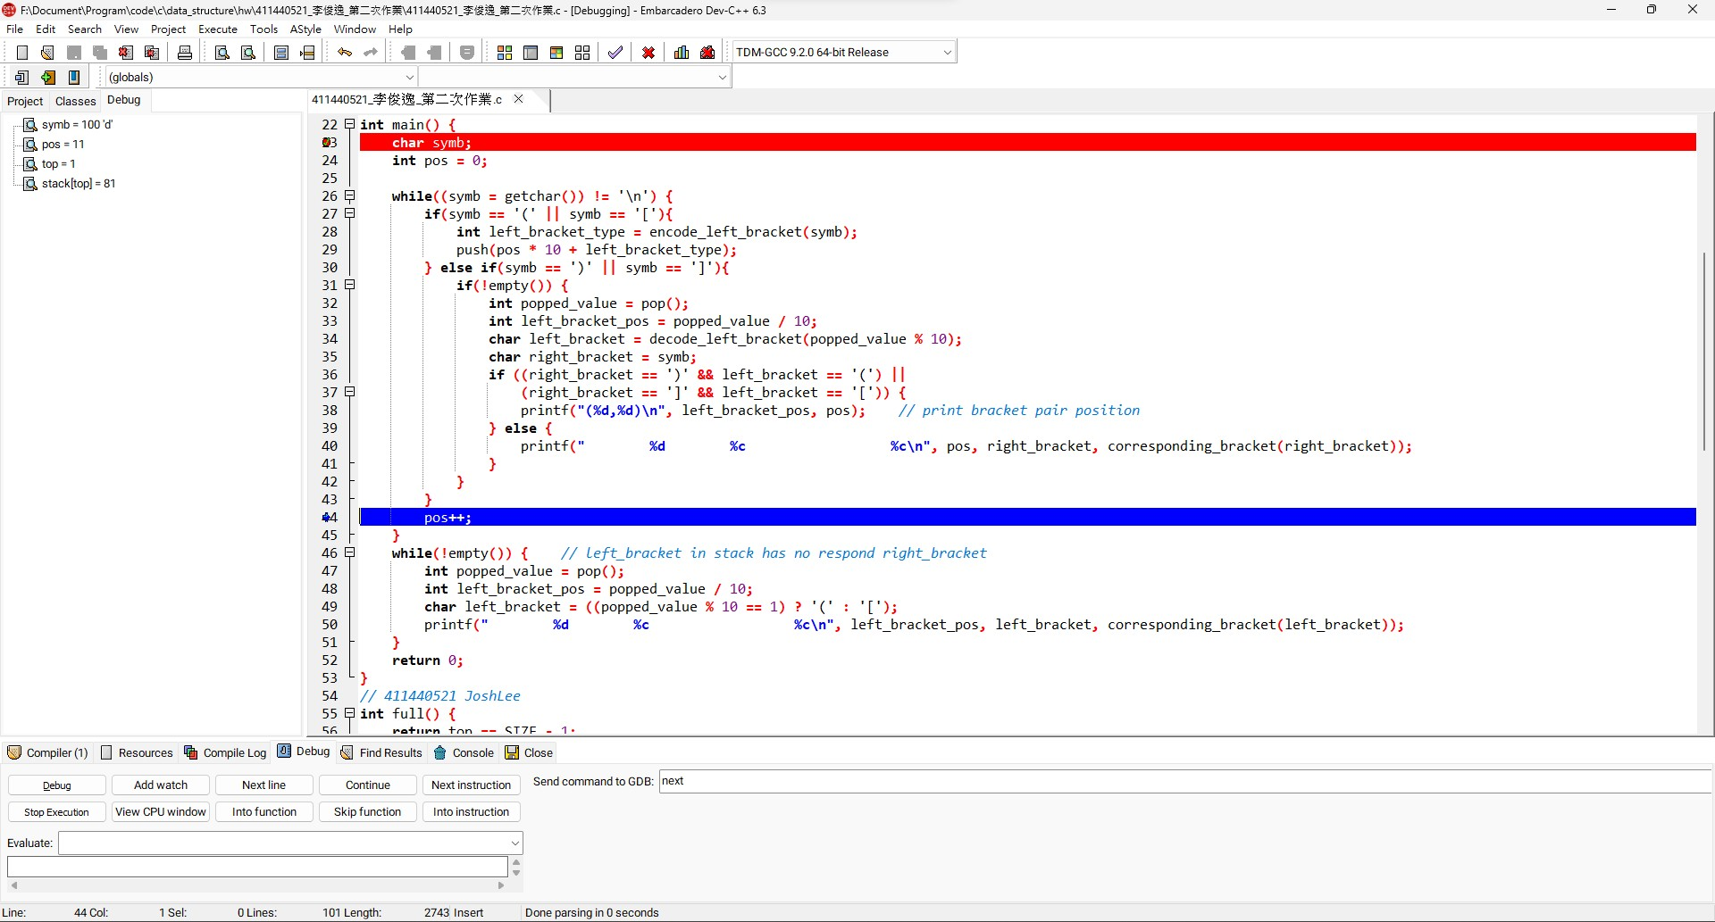

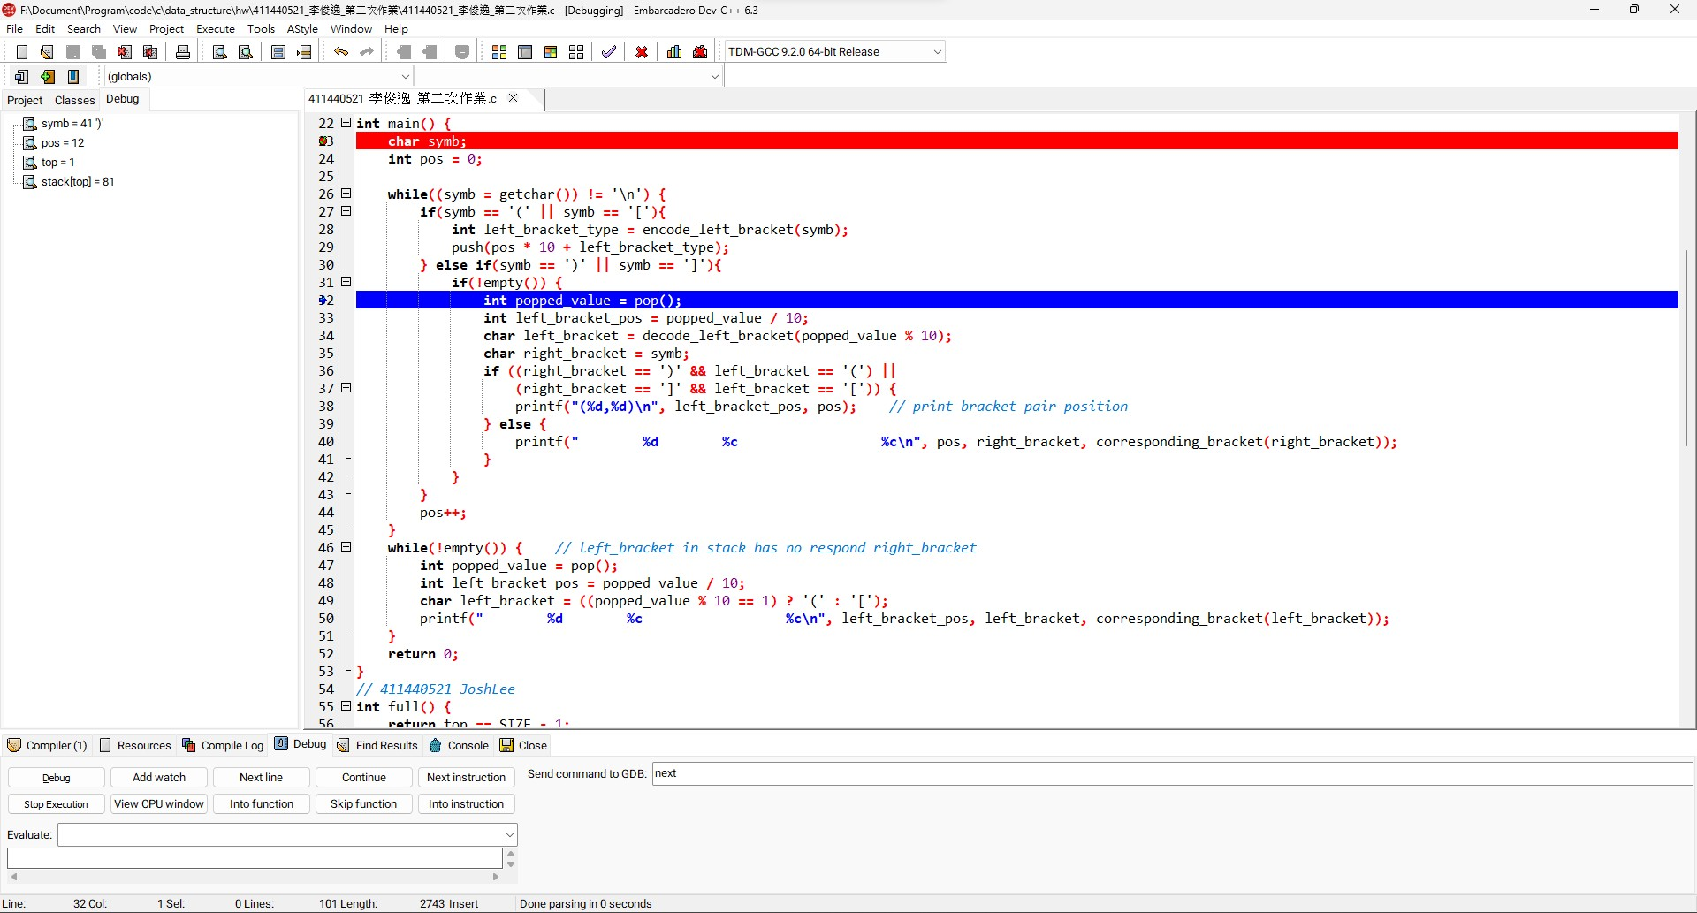

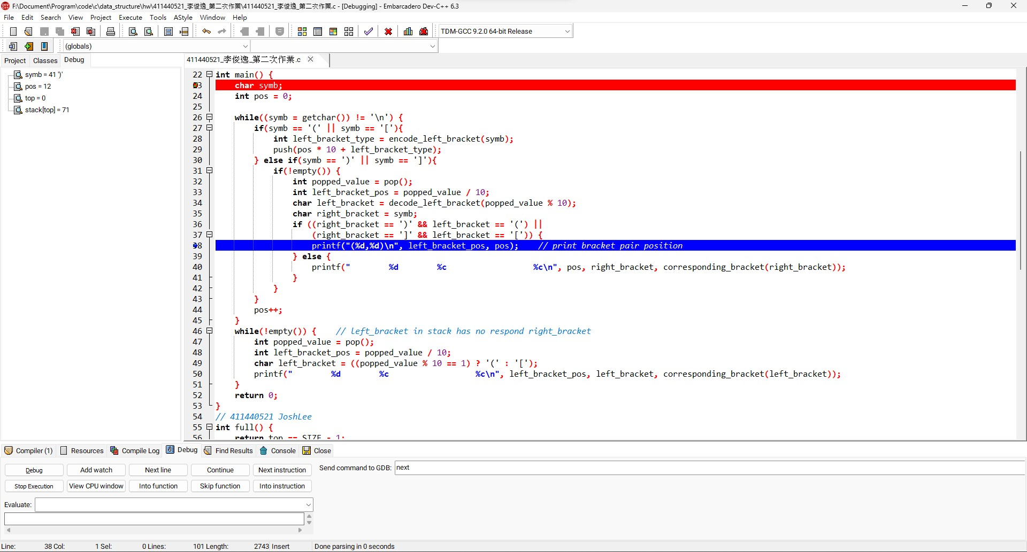

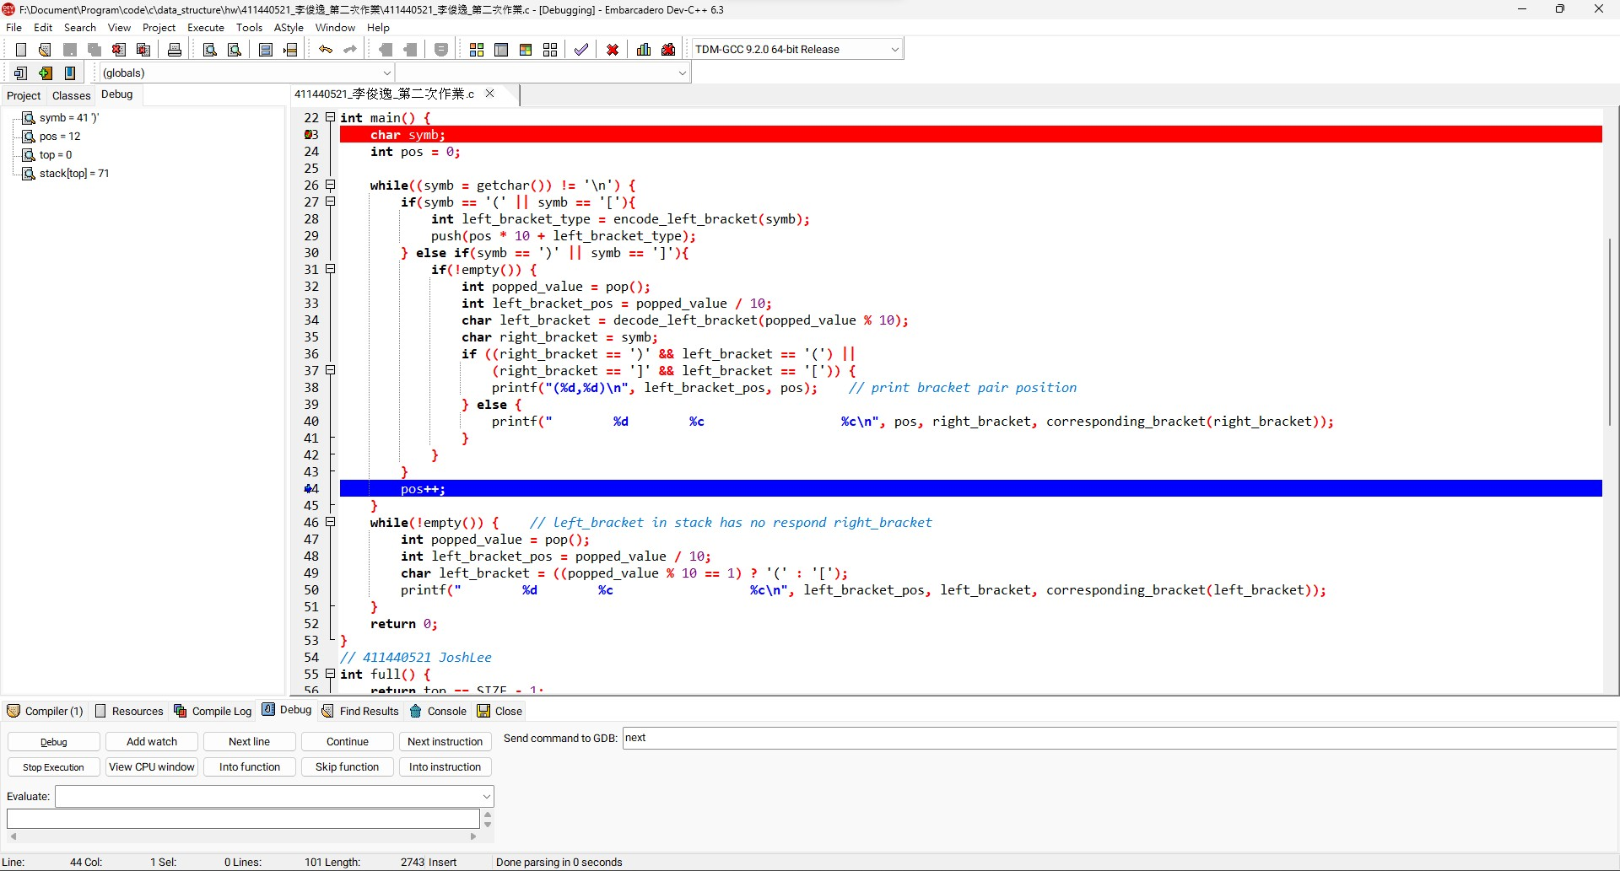

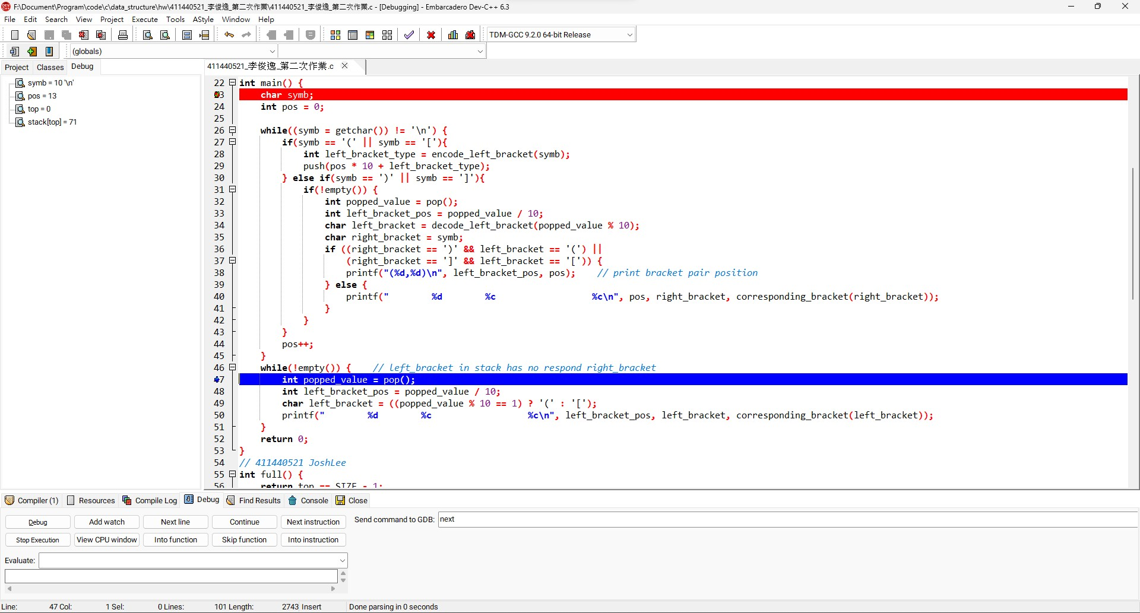

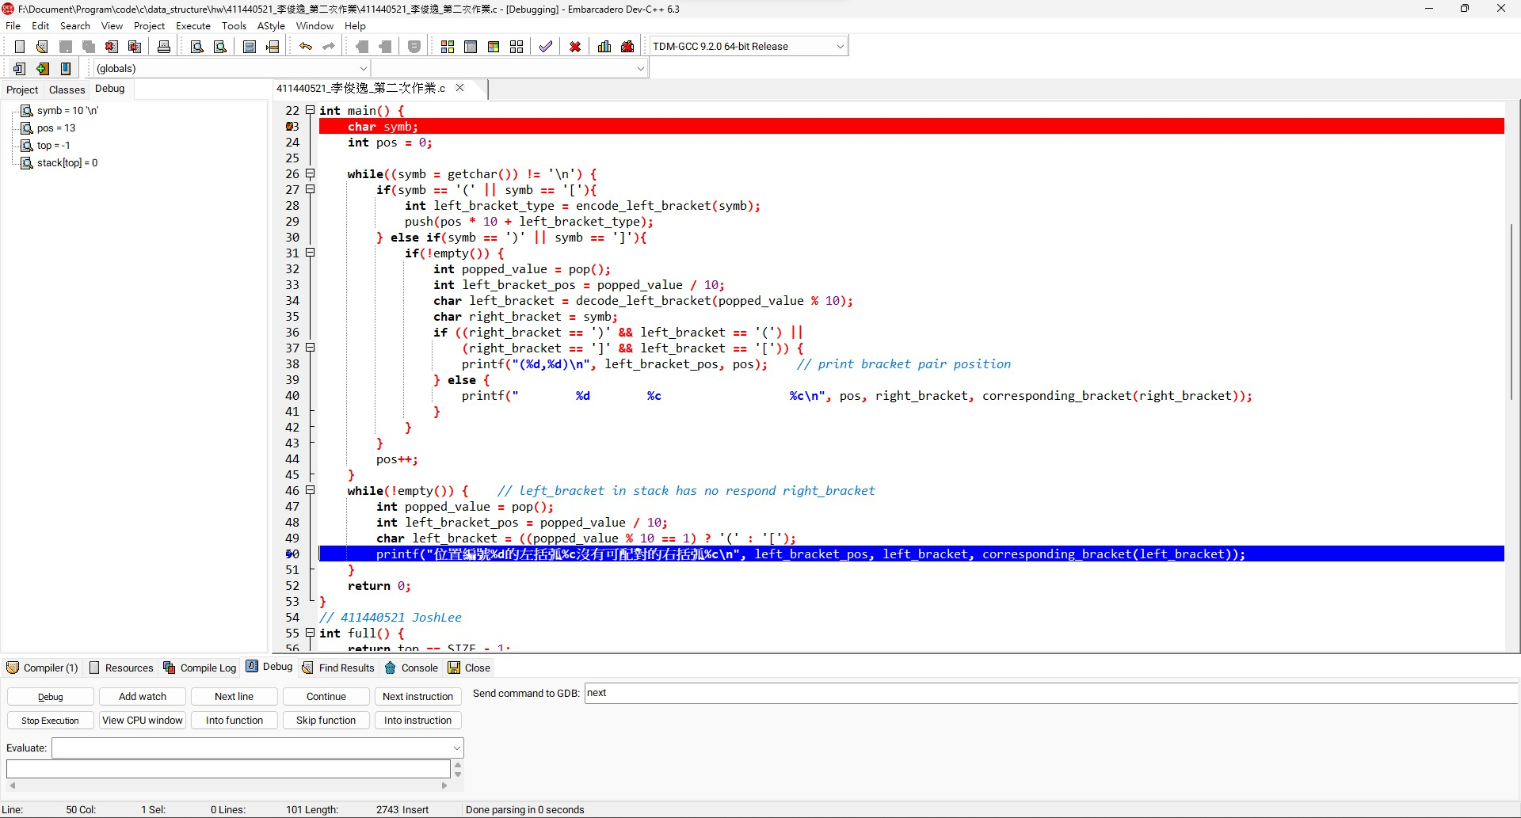

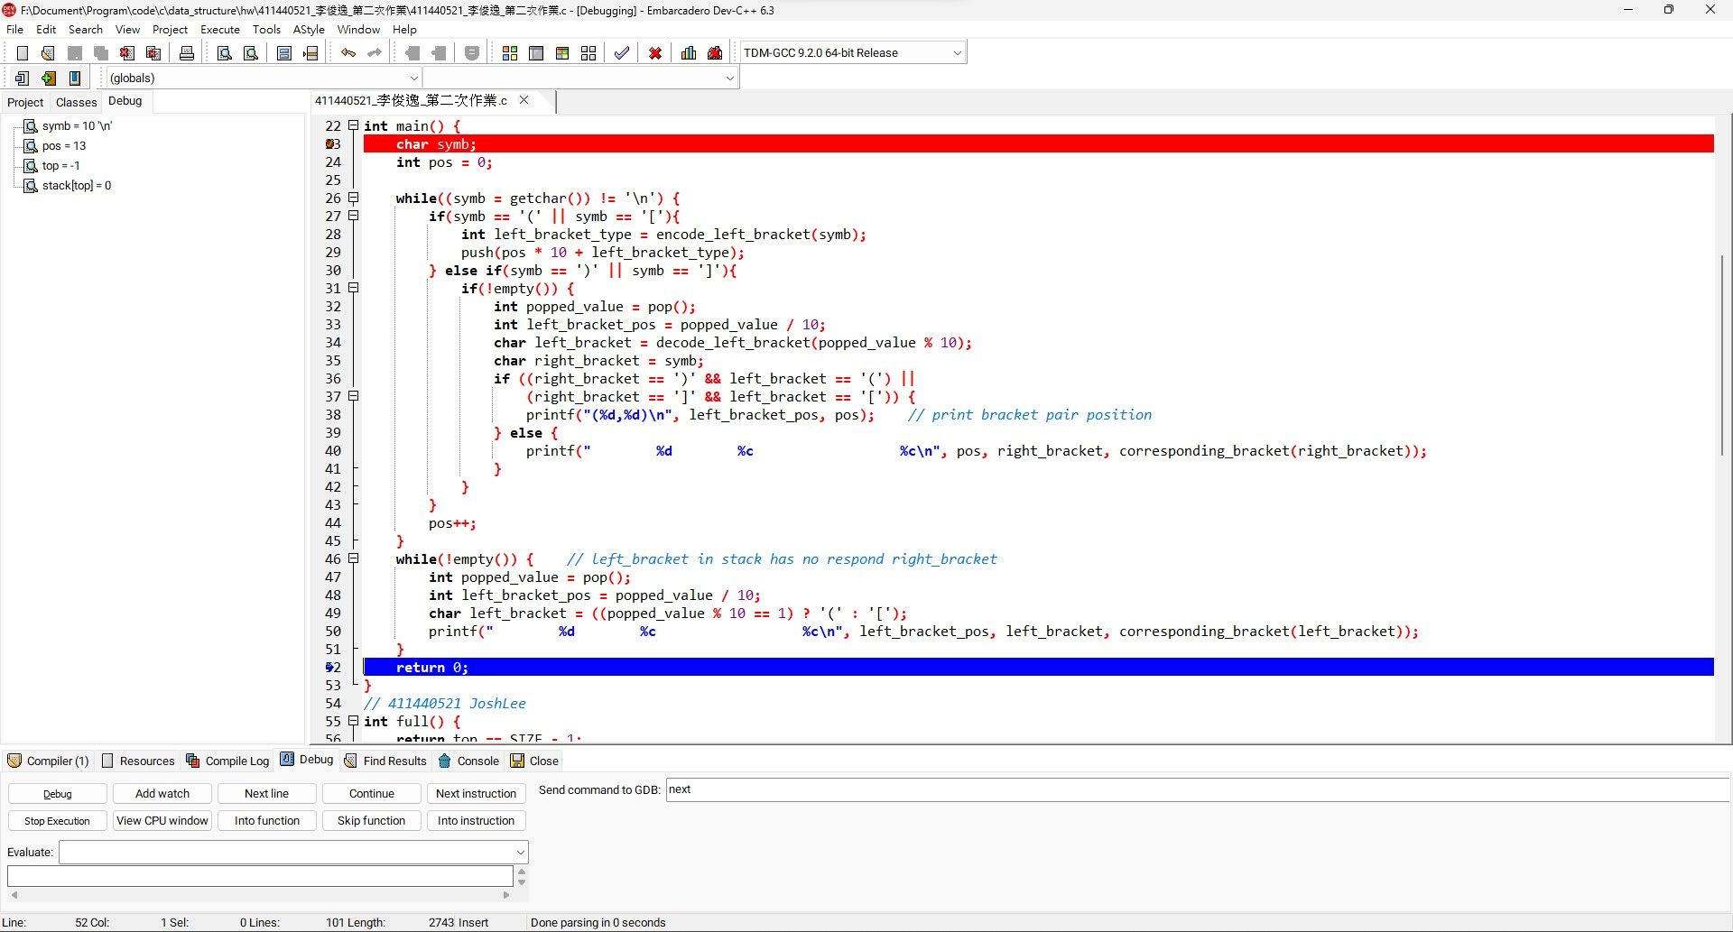

1. (((a+b)]*[[[c+d)]

(2,6)

位置編號7的右括弧]沒有可配對的左括弧[

位置編號15的右括弧)沒有可配對的左括弧(

(10,16)

位置編號9的左括弧[沒有可配對的右括弧]

位置編號0的左括弧(沒有可配對的右括弧)

位置編號9的左括弧[沒有可配對的右括弧]

位置編號0的左括弧(沒有可配對的右括弧)

[ 10

[ 9

( 0

( 1

( 0

遇到 ) @6

pop()最上層的( @2

(2,6)

[ 11

[ 10

[ 9

( 0

遇到 ] @7

pop()最上層的( @1，但發現不是對應的左括弧

位置編號7的右括弧]沒有可配對的左括弧[

遇到 ) @15

pop()最上層的[ @11，但發現不是對應的左括弧

( 2

( 1

( 0

位置編號7的左括弧(沒有可配對的右括弧)

位置編號15的右括弧)沒有可配對的左括弧(

遇到 ] @16

pop()最上層的( @10

(2,6)

[ 9

( 0

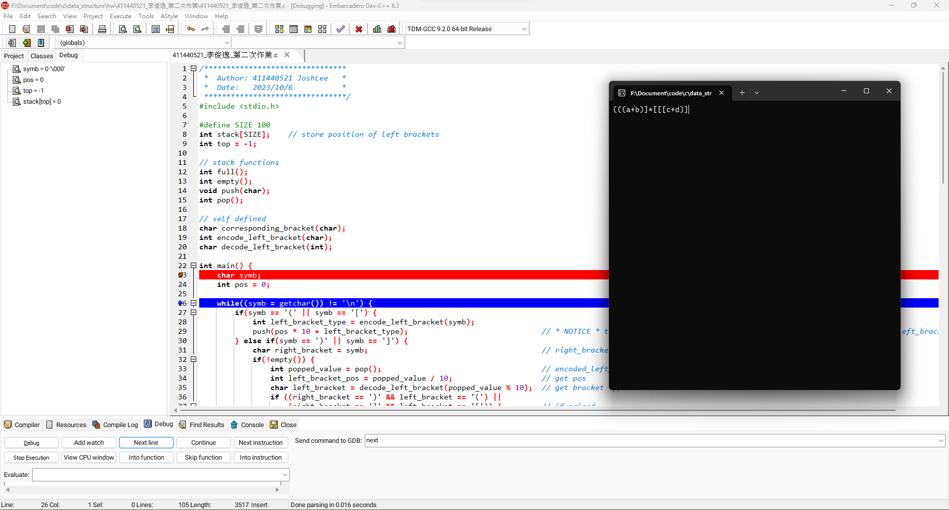

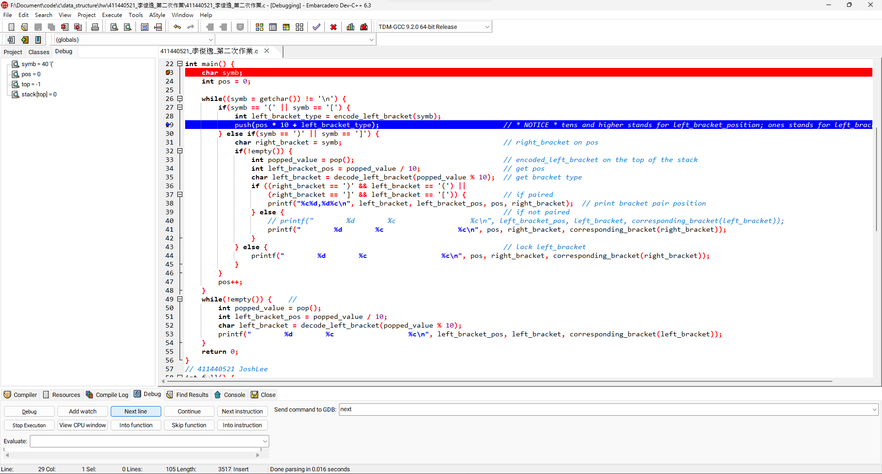

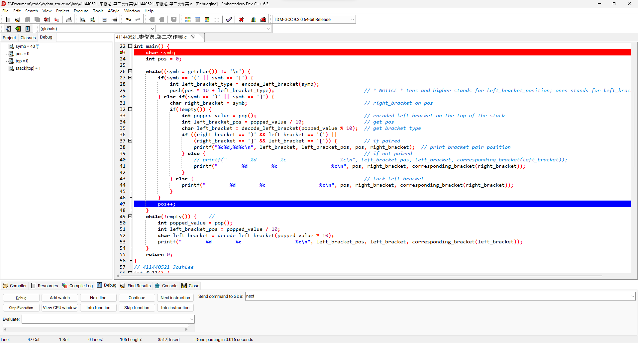

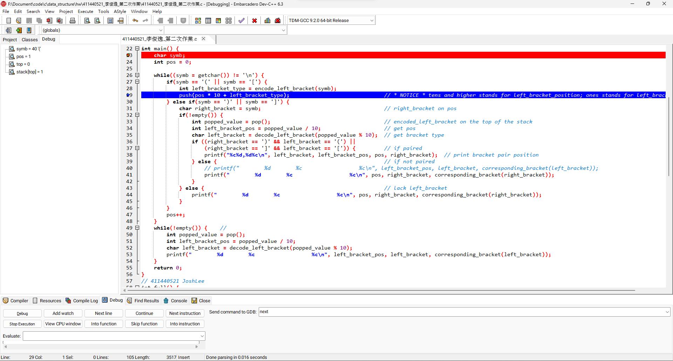

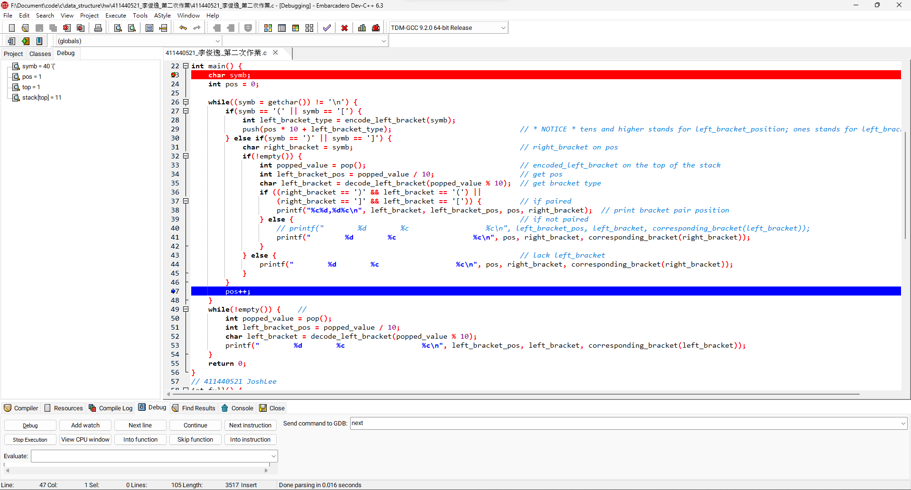

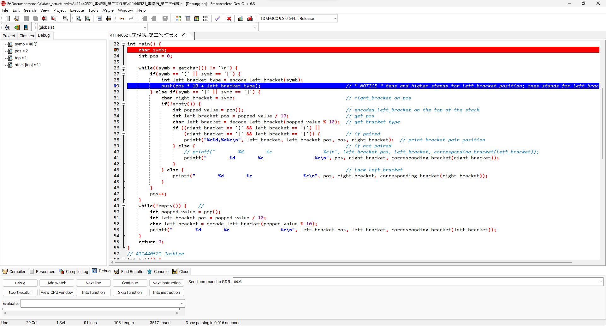

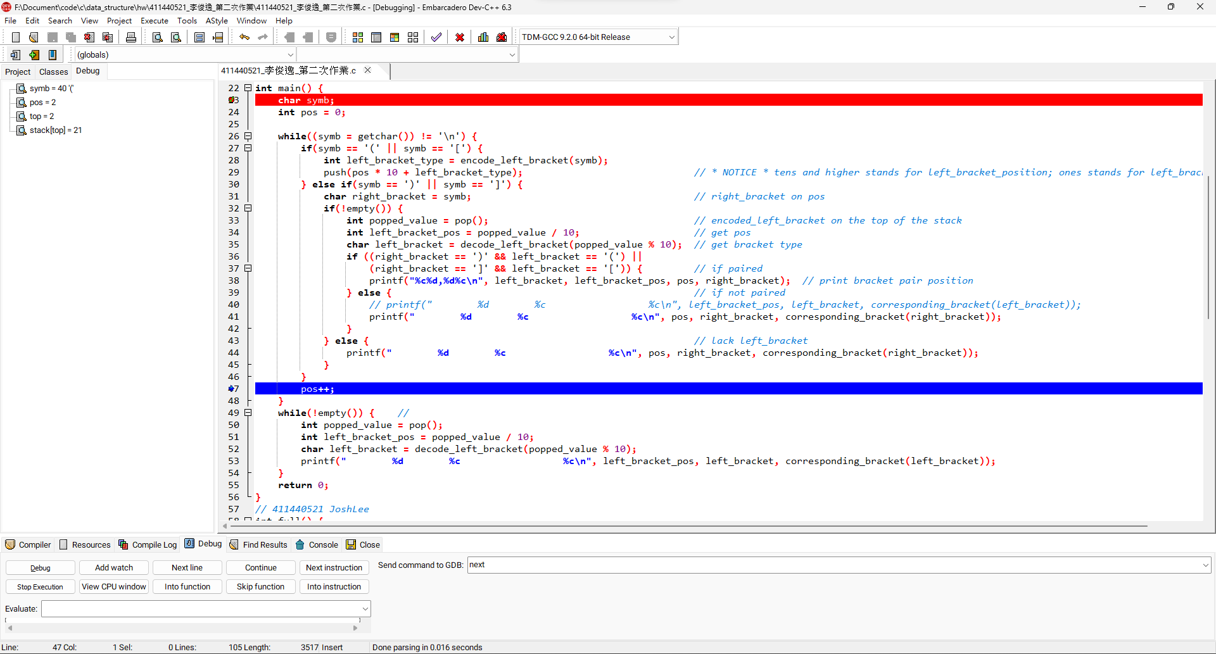

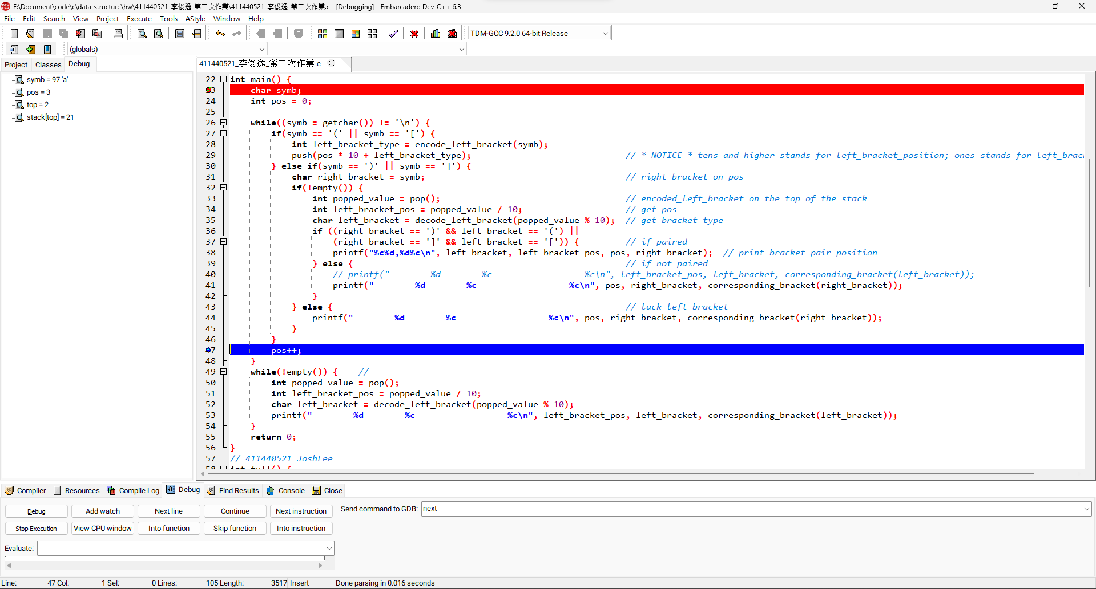

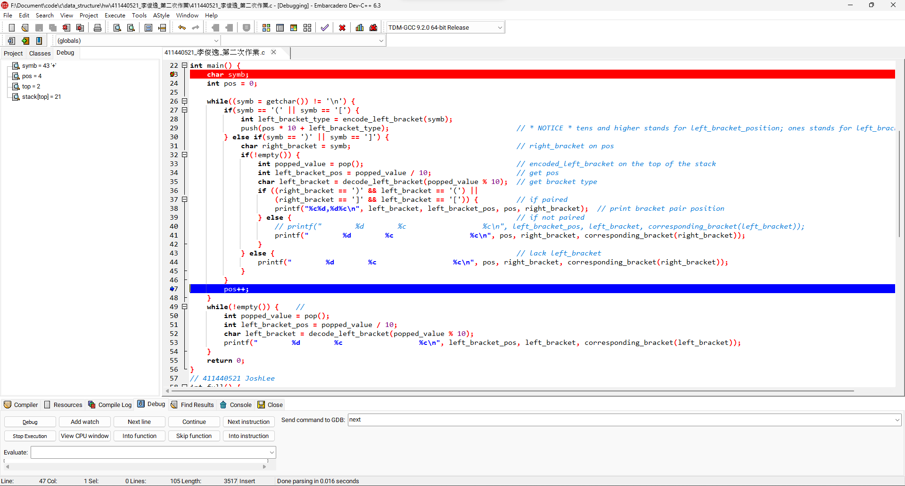

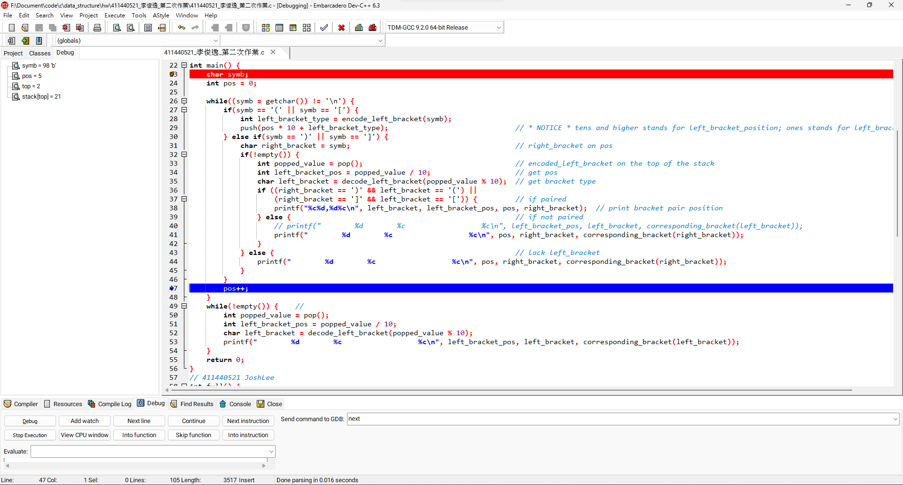

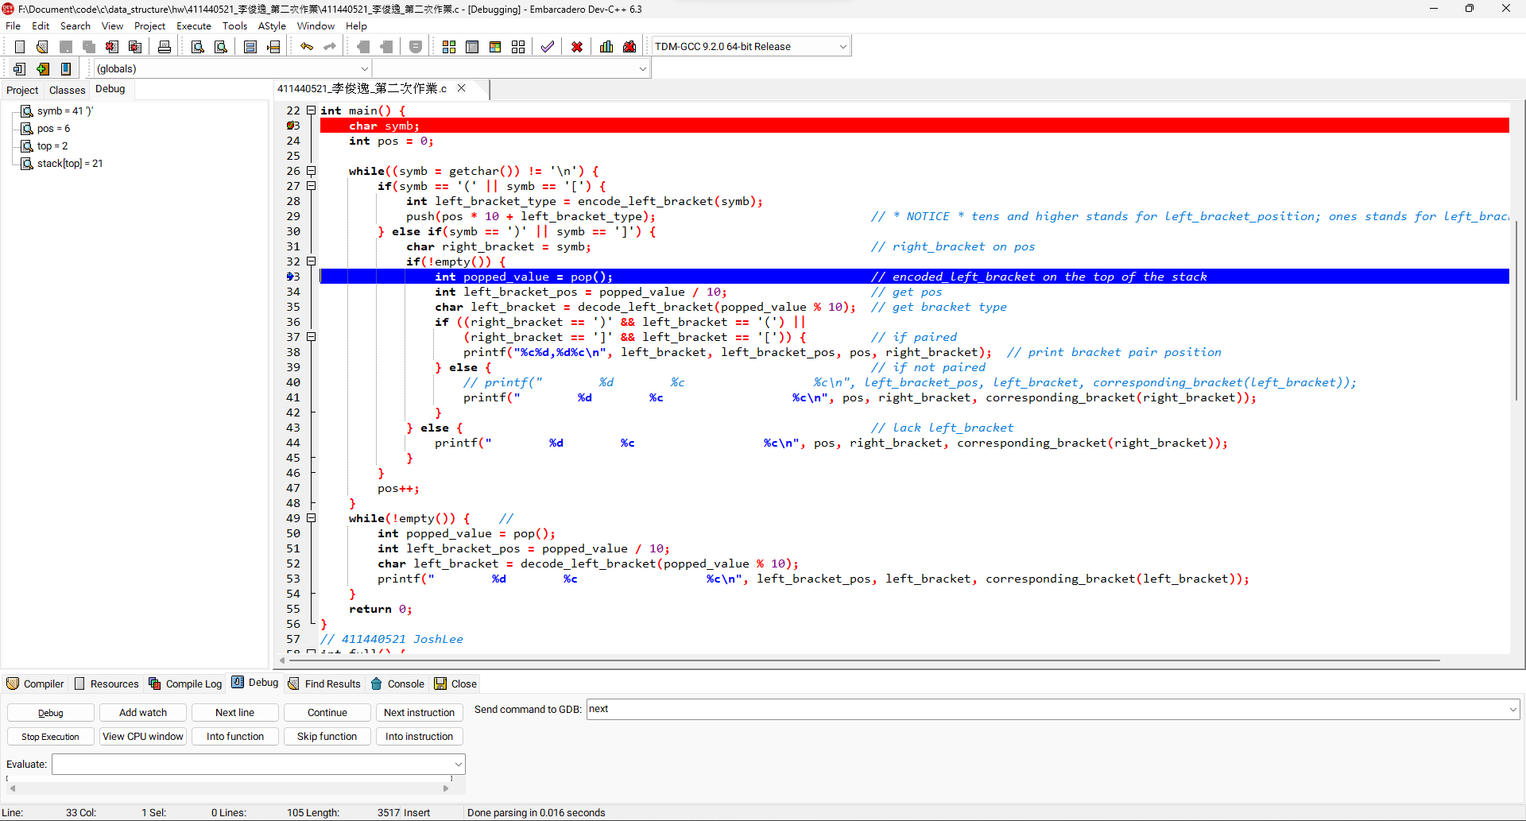

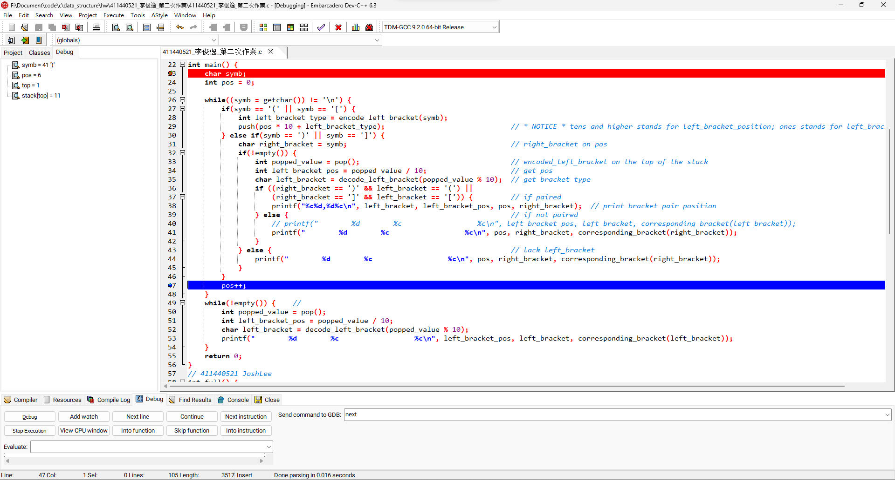

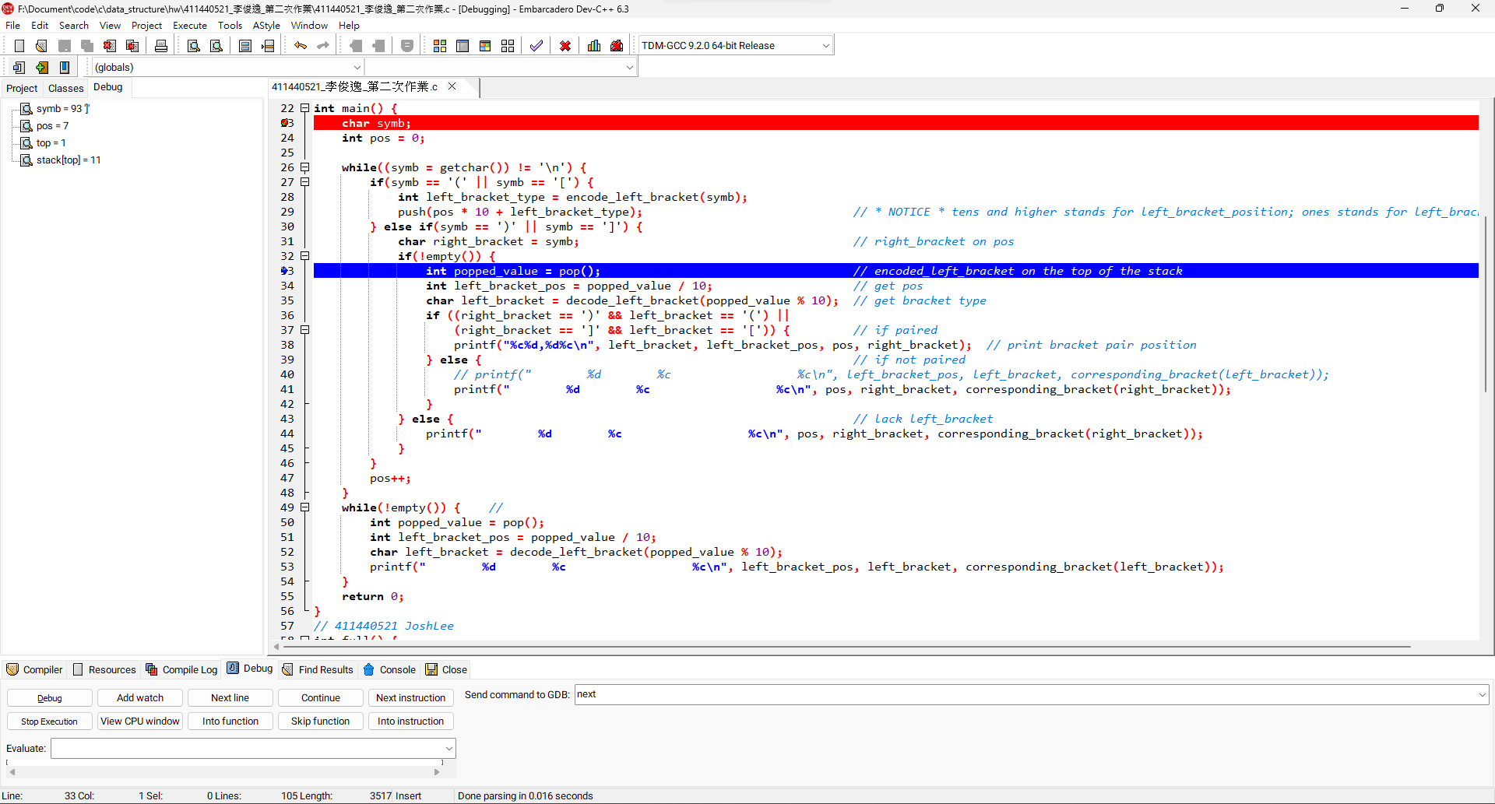

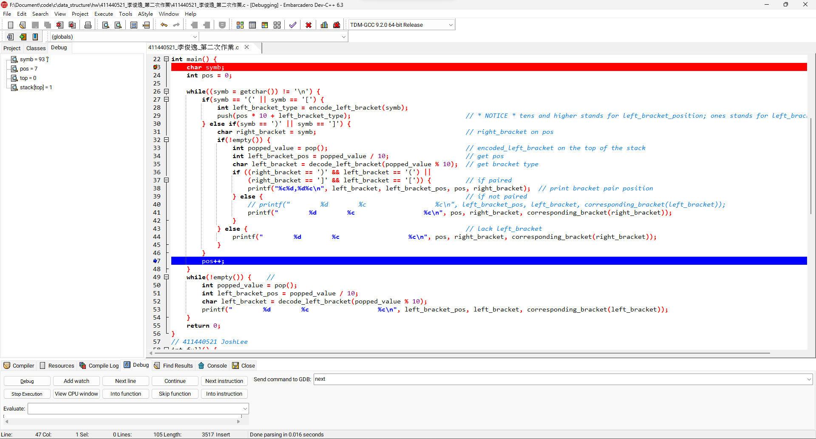

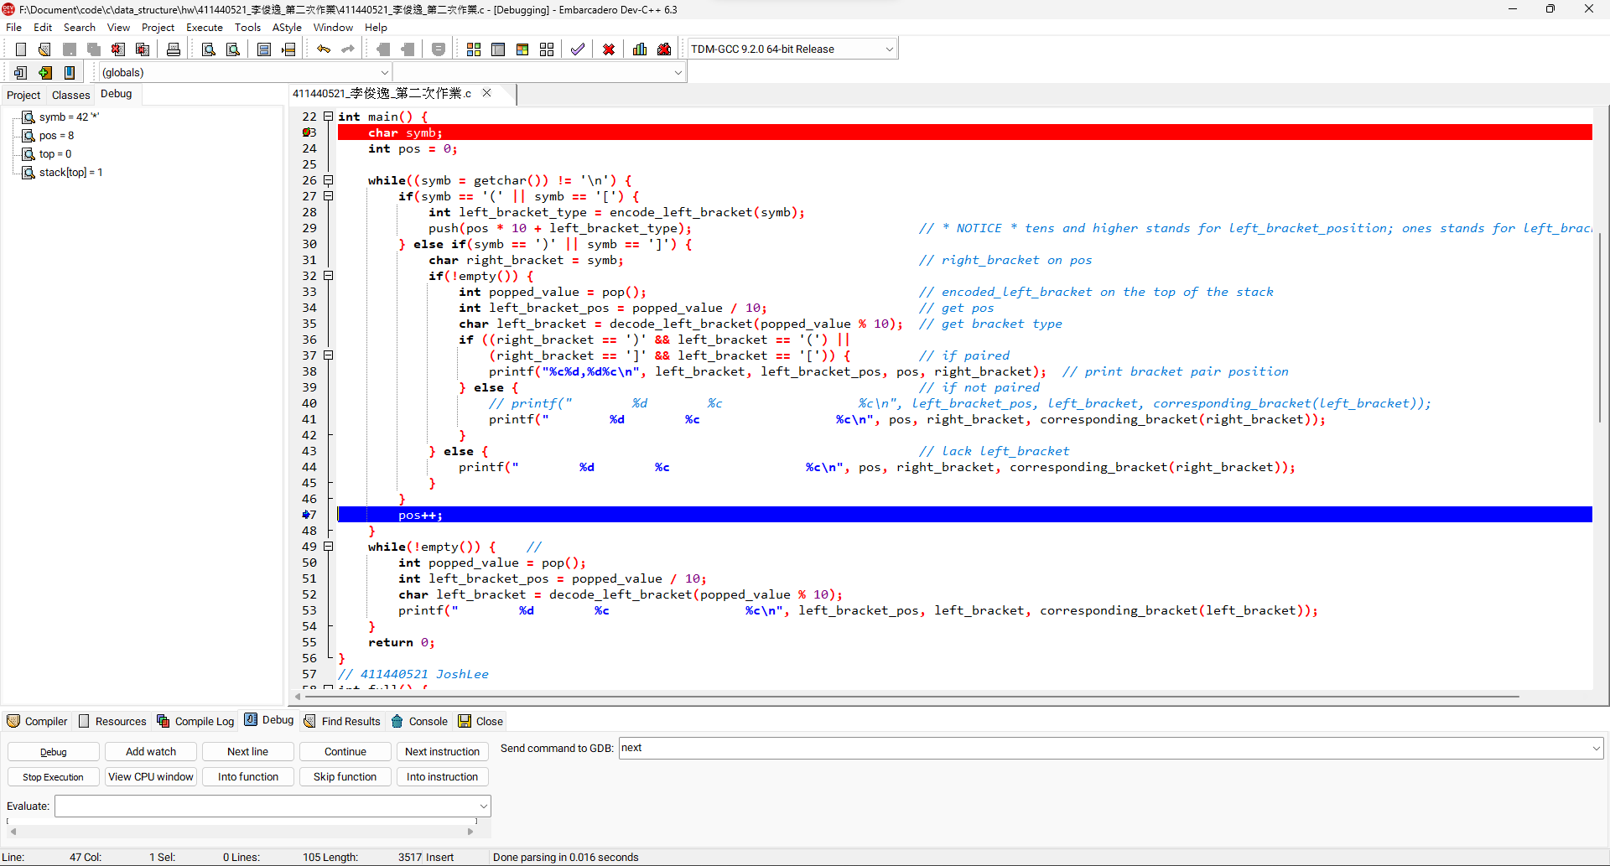

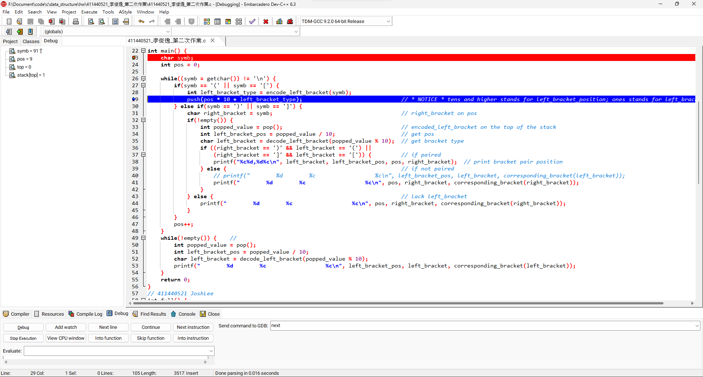

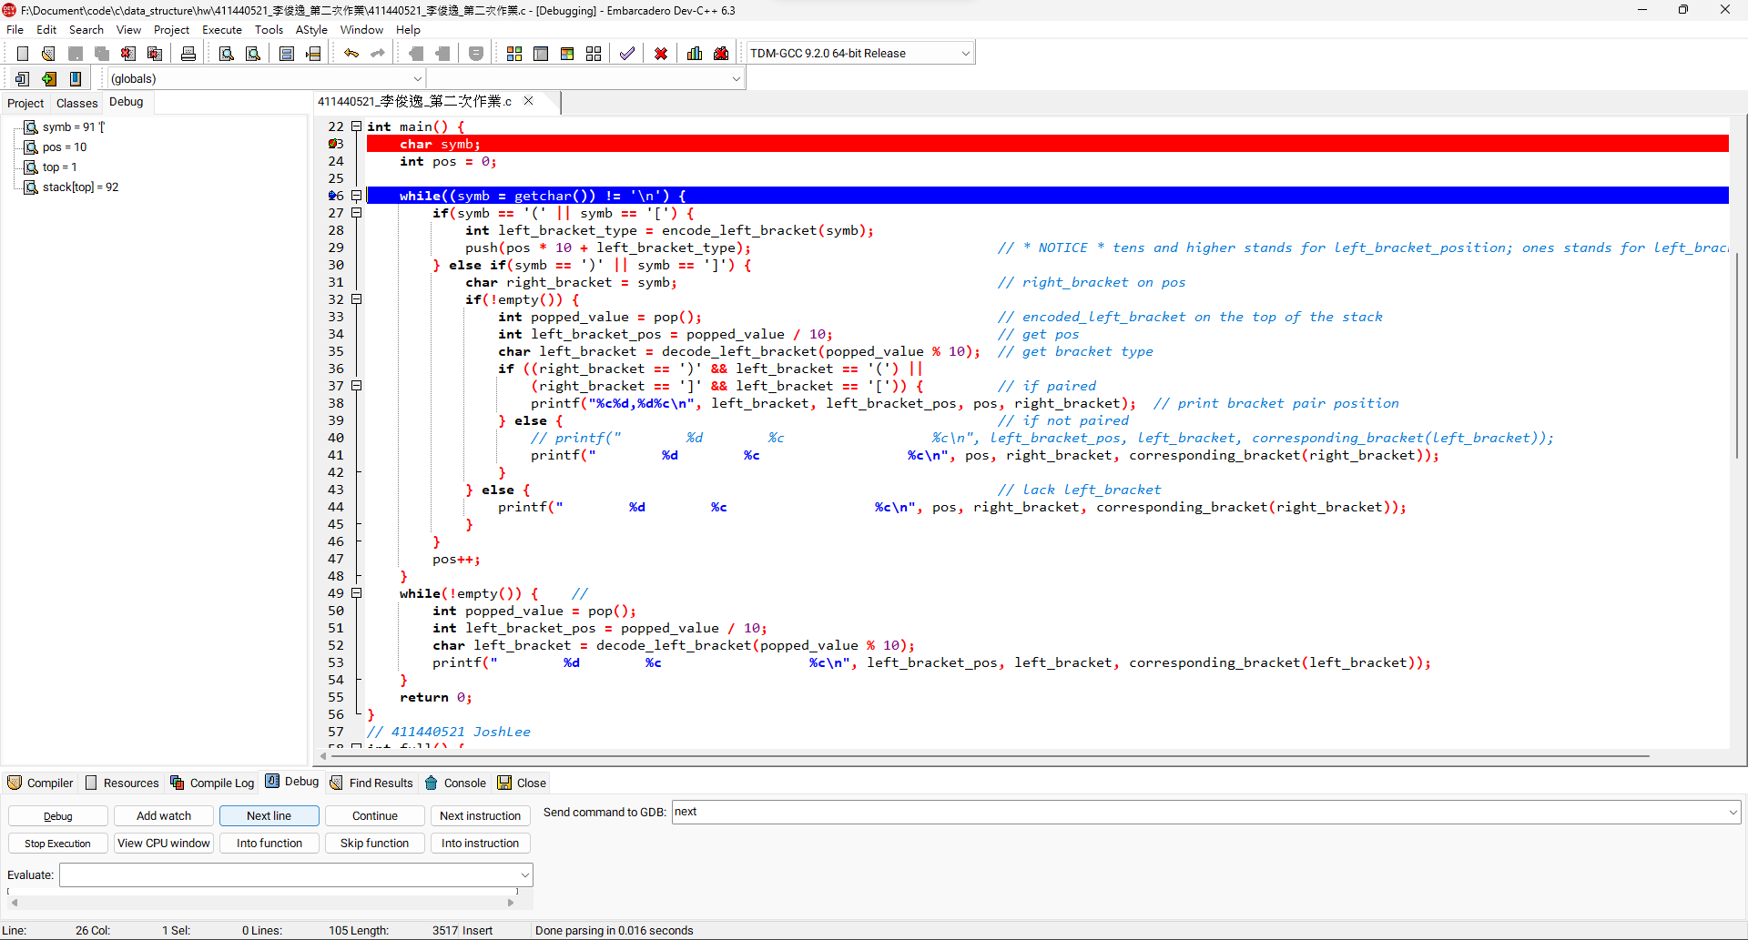

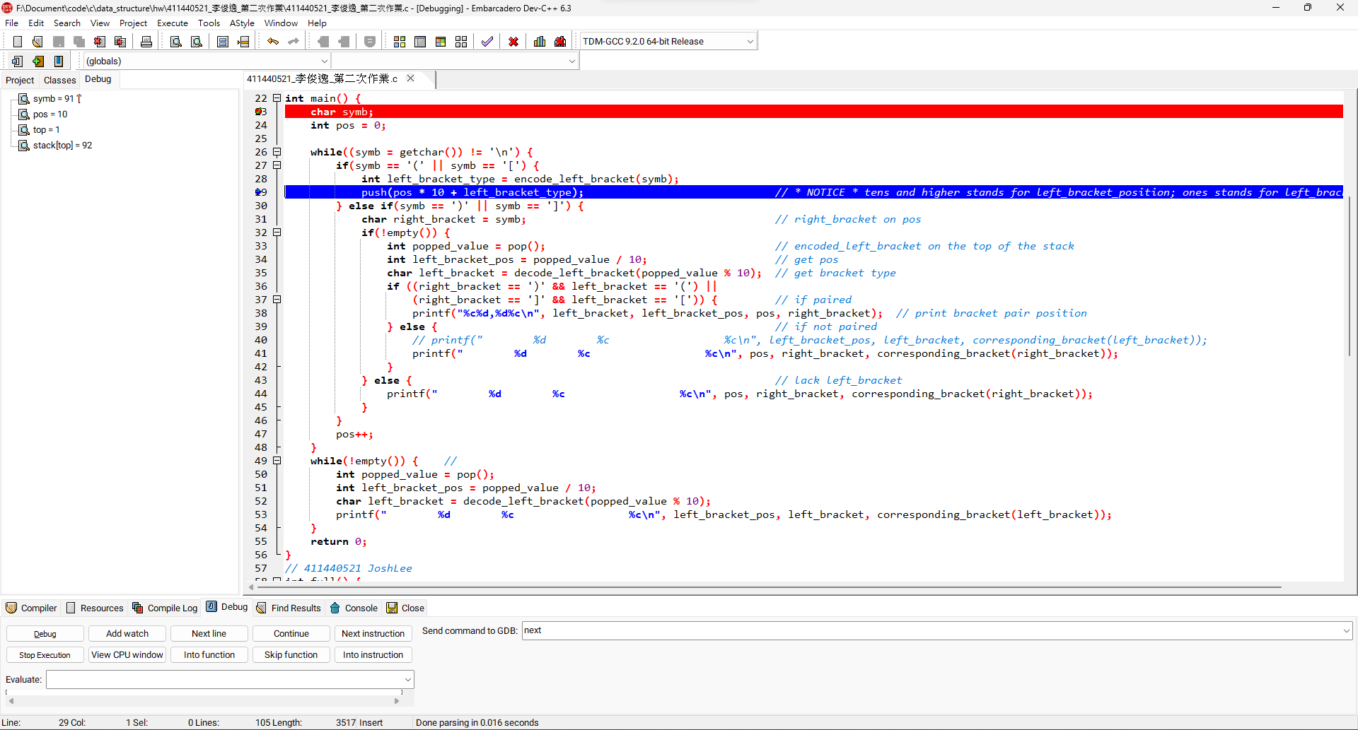

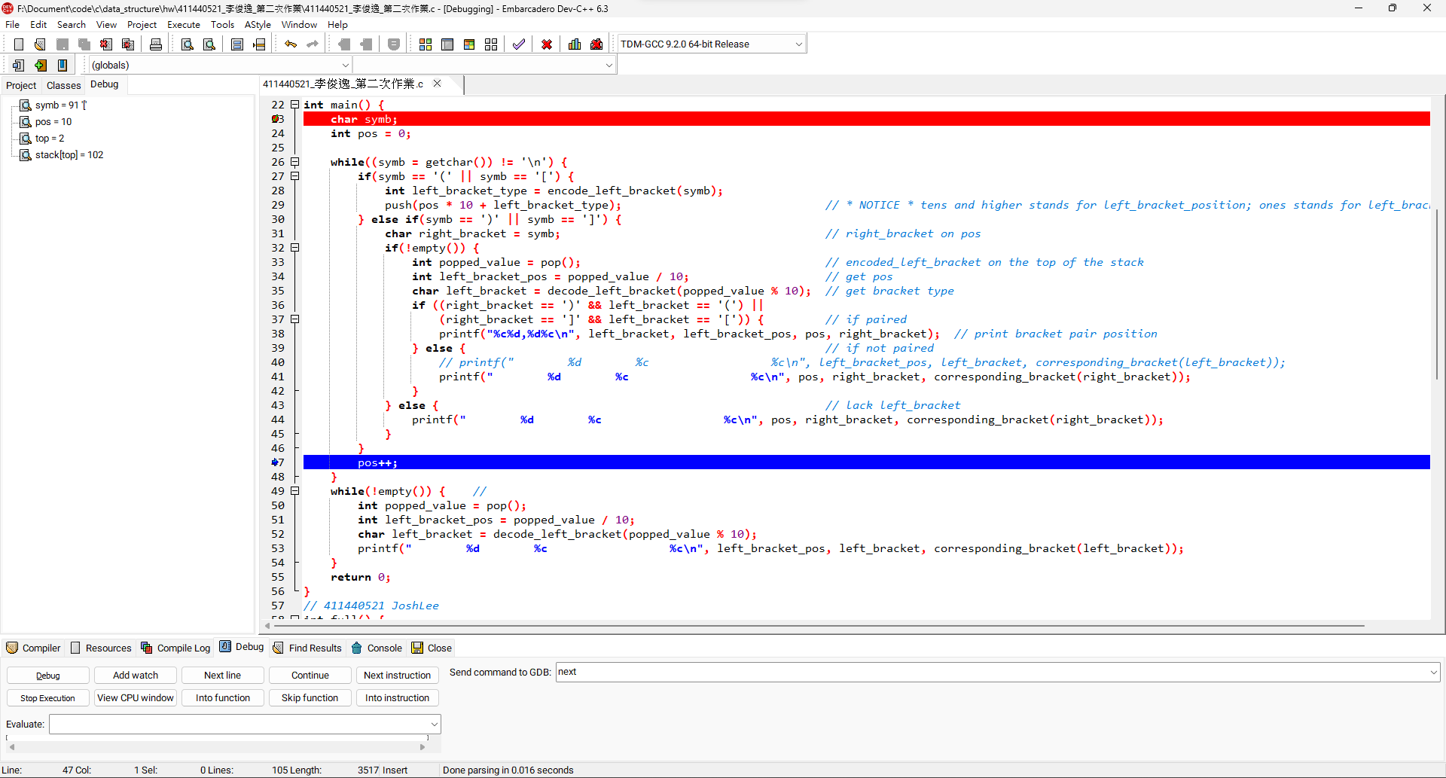

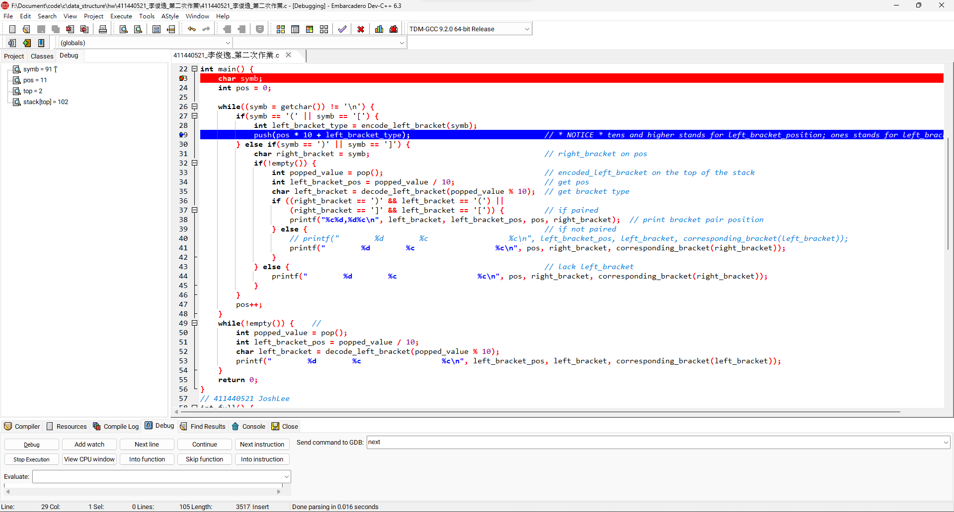

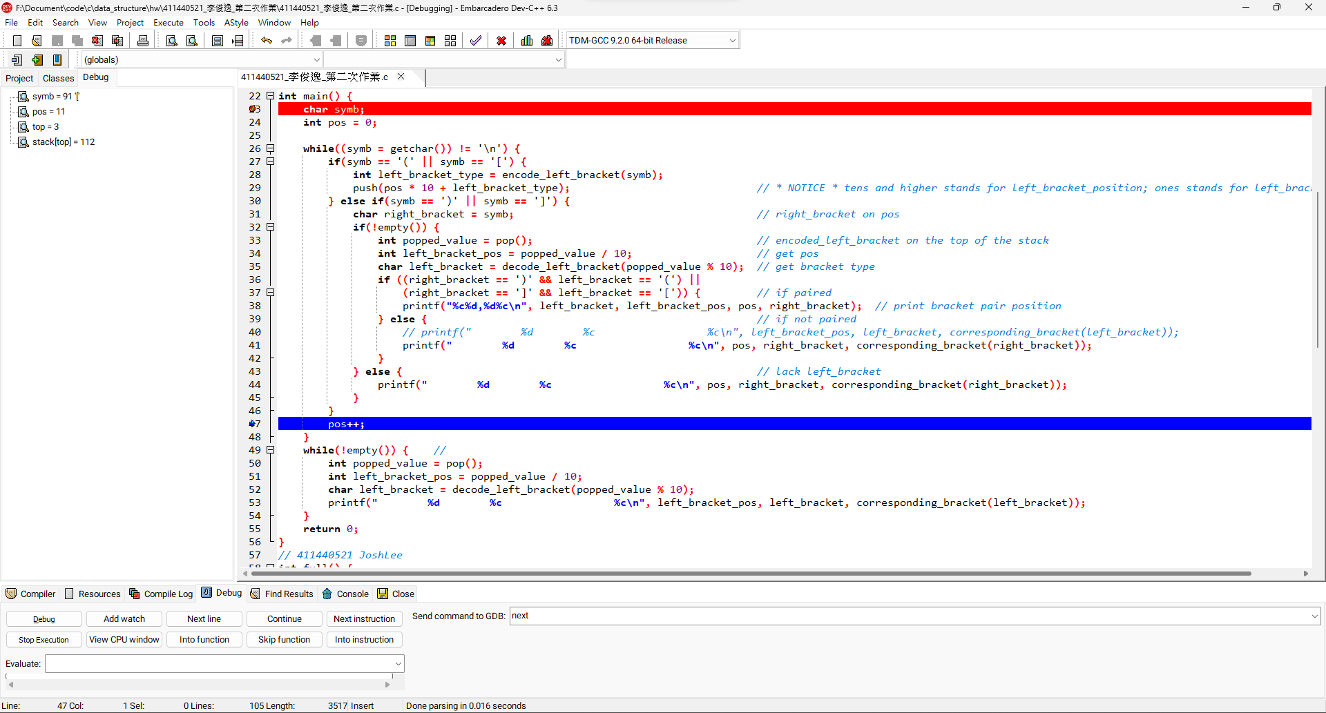

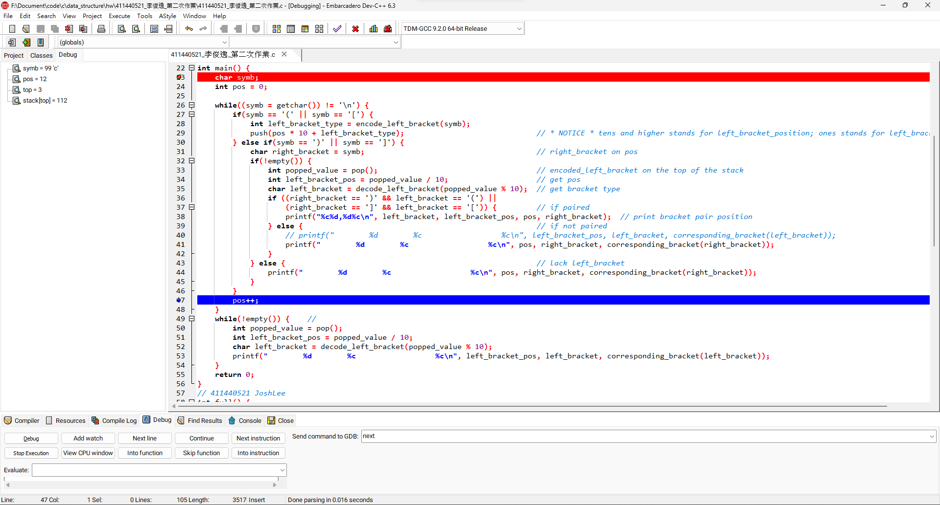

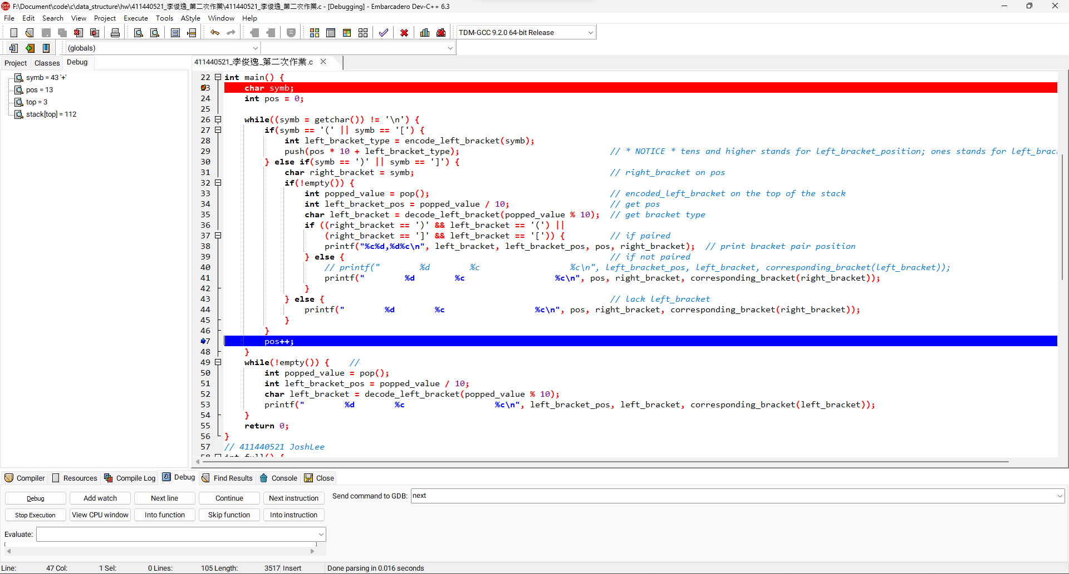

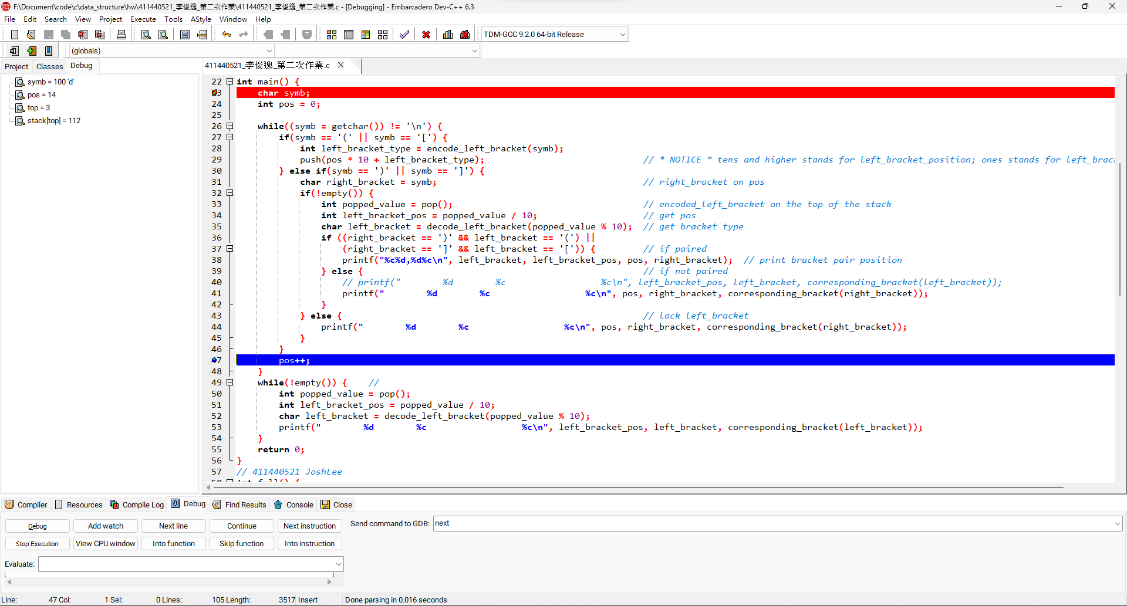

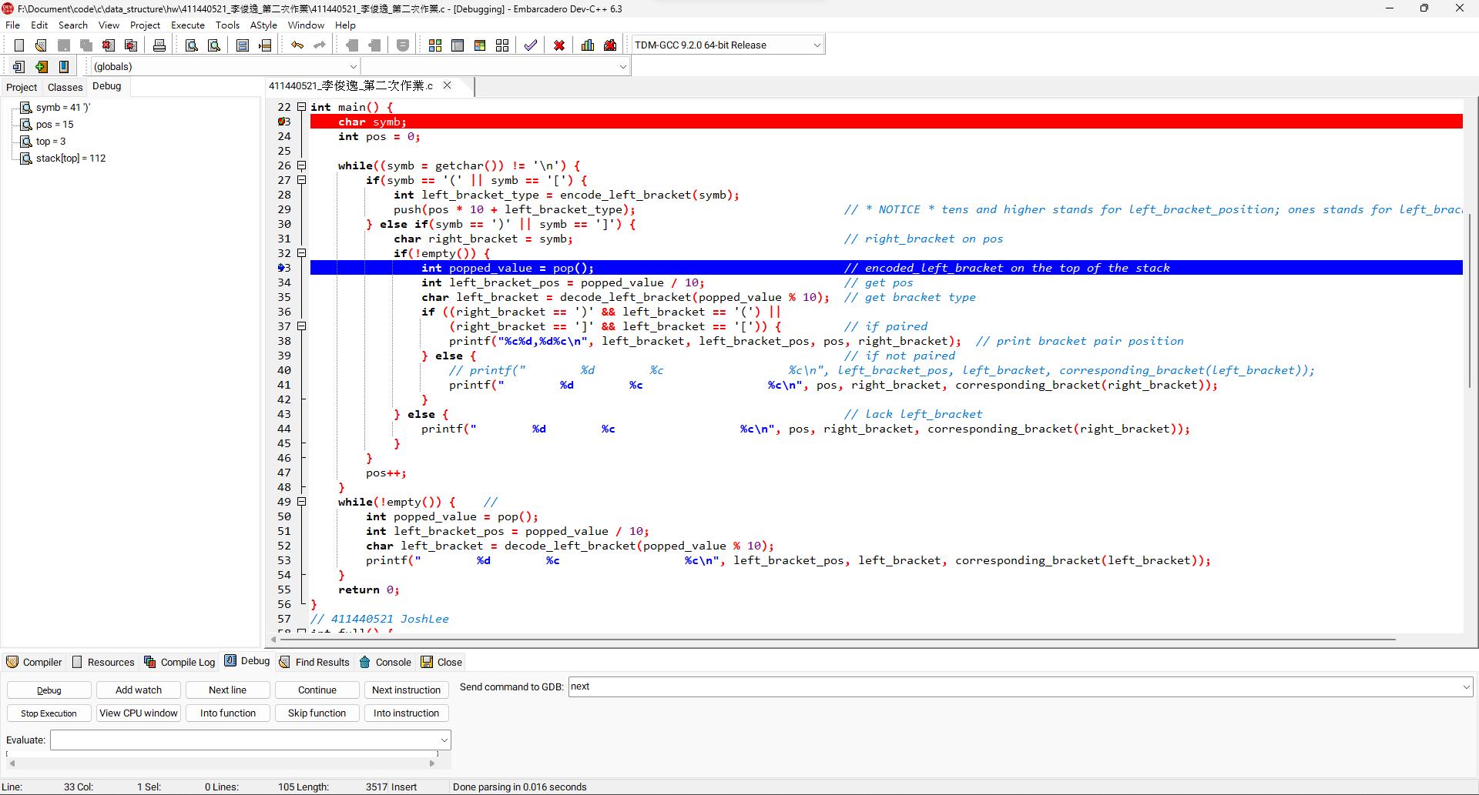

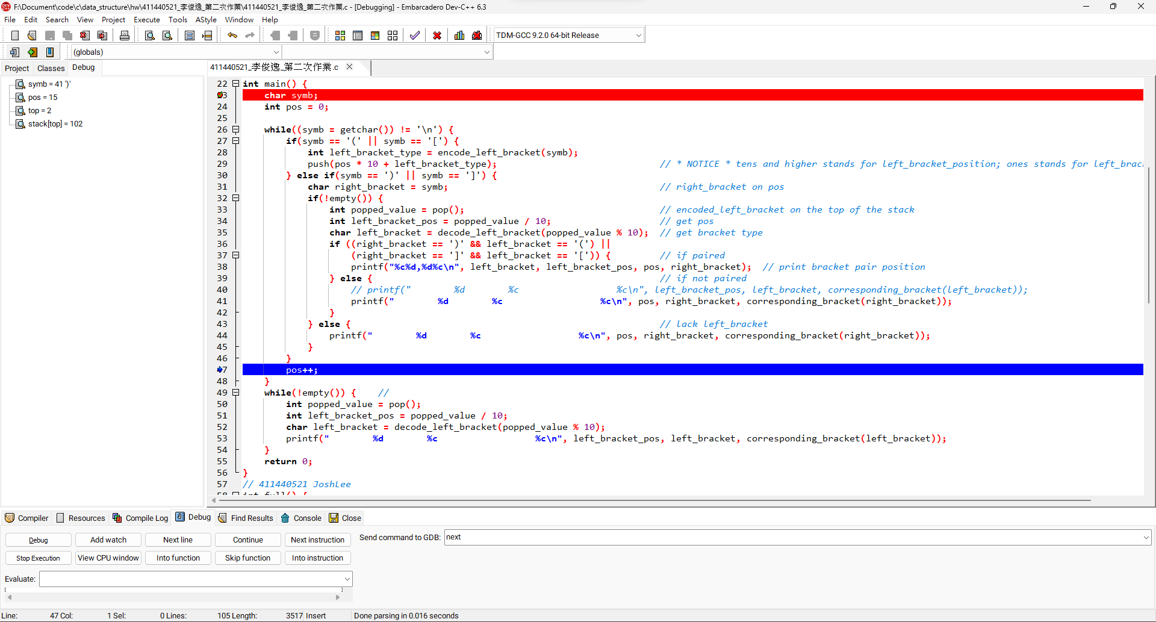

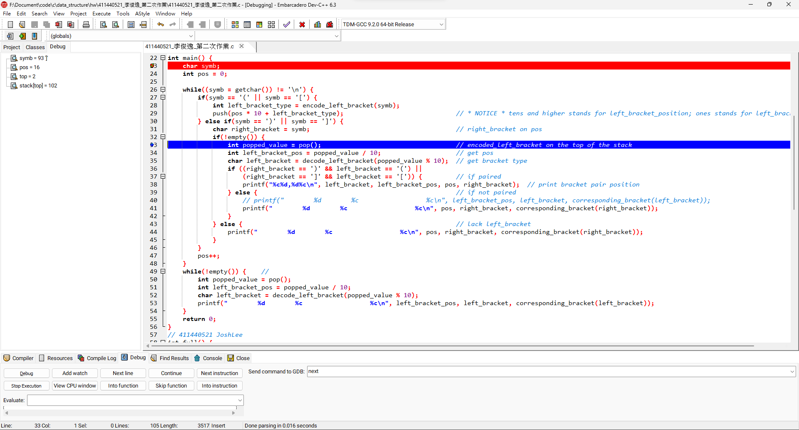

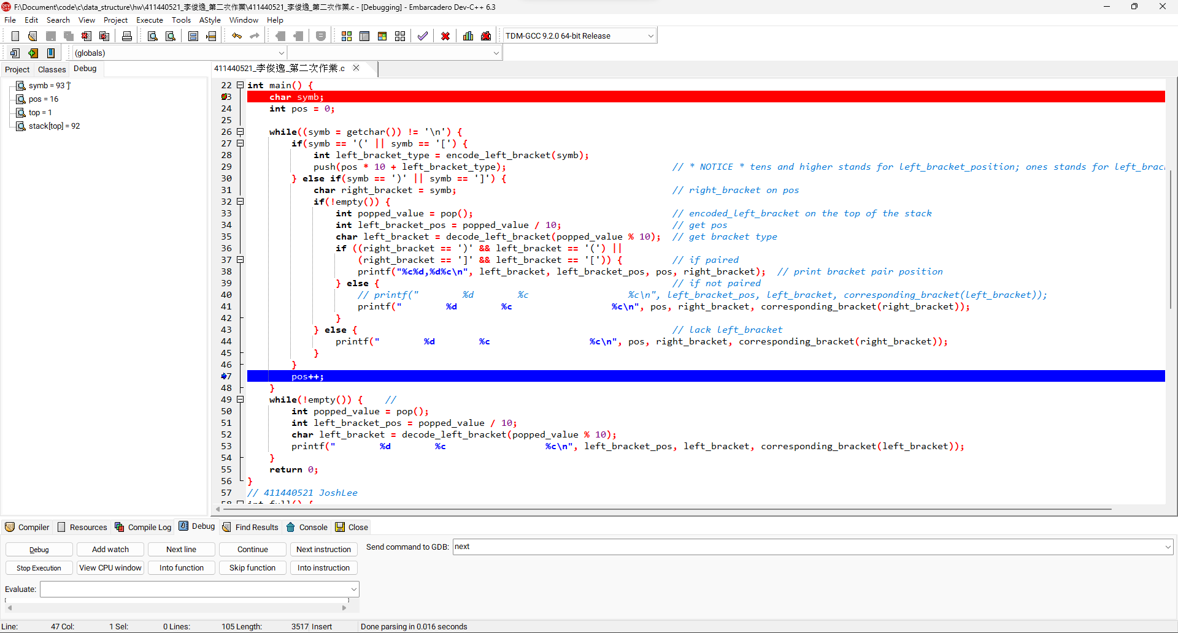

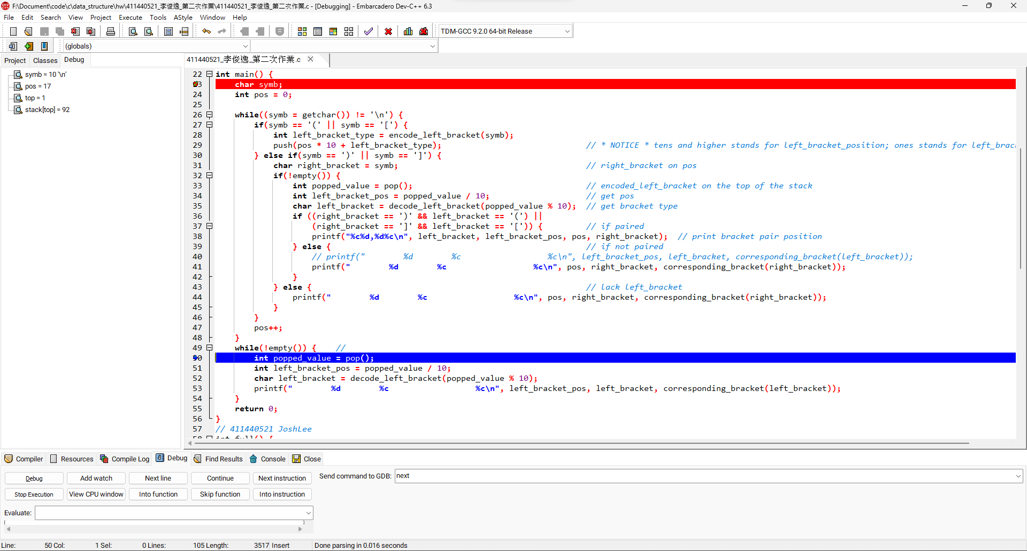

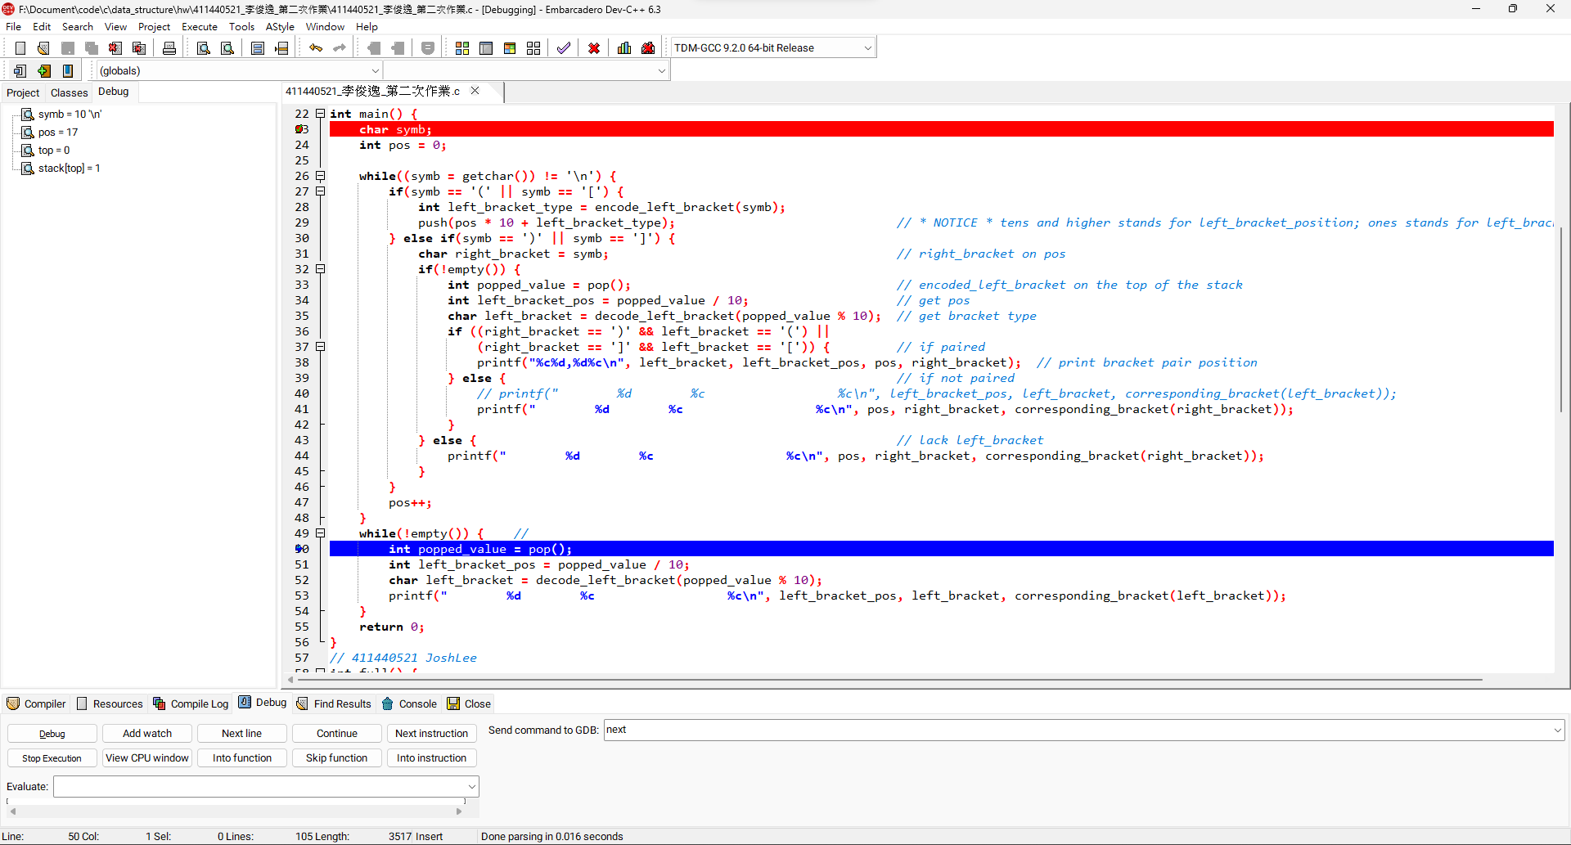

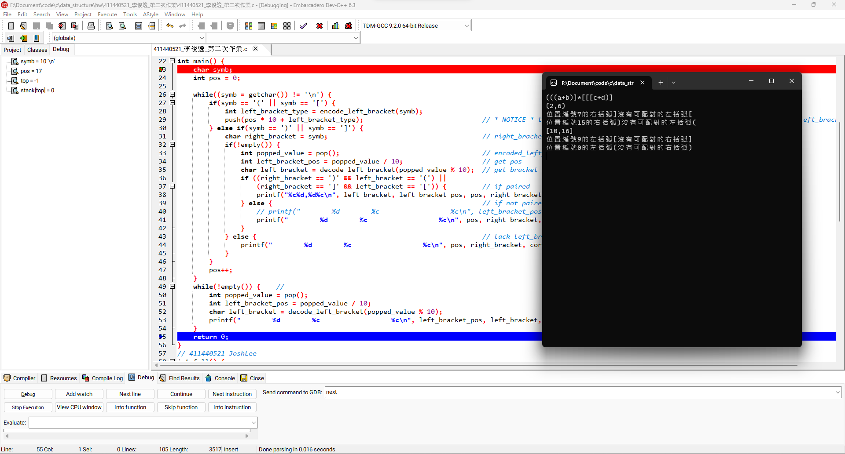

**完整程式碼:**

|  |  |
| --- | --- |
| |  | | --- | | #include <stdio.h>  #define SIZE 100  int stack[SIZE]; *// store position of left brackets*  int top = -1;  *// stack functions*  int full();  int empty();  void push(char);  int pop();  *// self defined*  char corresponding_bracket(char);  int encode_left_bracket(char);  char decode_left_bracket(int);  int main() {  char symb;  int pos = 0;    while((symb = getchar()) != '\n') {  if(symb == '(' || symb == '['){  int left_bracket_type = encode_left_bracket(symb);  push(pos * 10 + left_bracket_type);  } else if(symb == ')' || symb == ']'){  char right_bracket = symb; *// right_bracket on pos*  if(!empty()) {  int popped_value = pop(); *// encoded_left_bracket on the top of the stack*  int left_bracket_pos = popped_value / 10; *// get pos*  char left_bracket = decode_left_bracket(popped_value % 10); *// get bracket type*  if ((right_bracket == ')' && left_bracket == '(') ||  (right_bracket == ']' && left_bracket == '[')) { *// if paired*  printf("%c%d,%d%c\n", left_bracket, left_bracket_pos, pos, right_bracket); *// print bracket pair position*  } else {  *// printf("位置編號%d的左括弧%c沒有可配對的右括弧%c\n", left_bracket_pos, left_bracket, corresponding_bracket(left_bracket));*  printf("位置編號%d的右括弧%c沒有可配對的左括弧%c\n", pos, right_bracket, corresponding_bracket(right_bracket));  }  } else {  printf("位置編號%d的右括弧%c沒有可配對的左括弧%c\n", pos, right_bracket, corresponding_bracket(right_bracket));  }  }  pos++;  }  while(!empty()) { *// 在堆疊裡的左括號都沒有右括號*  int popped_value = pop();  int left_bracket_pos = popped_value / 10;  char left_bracket = decode_left_bracket(popped_value % 10);  printf("位置編號%d的左括弧%c沒有可配對的右括弧%c\n", left_bracket_pos, left_bracket, corresponding_bracket(left_bracket));  }  return 0;  }  int full() {  return top == SIZE - 1;  }  int empty() {  return top == -1;  }  void push(char c) {  if(!full())  stack[++top] = c;  else  printf("Stack is full!\n");  }  int peek() {  return stack[top];  }  int pop() {  if (!empty()) {  int popped_value = stack[top];  stack[top--] = 0;  return popped_value;  } else {  printf("Stack is empty!\n");  return -1;  }  }  char corresponding_bracket(char bracket) {  if(bracket == '(') return ')';  if(bracket == '[') return ']';  if(bracket == ')') return '(';  if(bracket == ']') return '[';  }  int encode_left_bracket(char bracket) {  if(bracket == '(') return 1;  if(bracket == '[') return 2;  }  char decode_left_bracket(int bracket) {  if(bracket == 1) return '(';  if(bracket == 2) return '[';  } | |